Dear Student,

2023-24 Semester-II, Mid semester MCQ examination of First year B.Tech students is scheduled on 2nd April 2024 and 3rd April 2024.
Following are the instructions for MCQ-MSE:-

1. Students should appear for Online MSE-MCQ examinations and DUMMY Exam from home using an internet enabled laptop through vierp software.
2. Students should Login using VIERP.
3. Students must ensure charging of laptops. (in case of electricity failure at student end).
4. Students must ensure availability of internet enabled Laptop. It is compulsory to give an exam using a laptop computer, no other device is permitted.
5. Students must give the exam as per given schedule as no re-examination will be scheduled if any student will miss the exam,
6. Students must keep videos on during exams. If the video is off, the exam will be paused by the proctor.
7. It is compulsory for students to join google meet/Zoom meeting, link will be shared by individual subject teacher (proctor)
8. Every student will get randomly selected questions from the subject's question bank; answer options will be shuffled for each student.
Refer to the following table for the number of questions per subject. :-
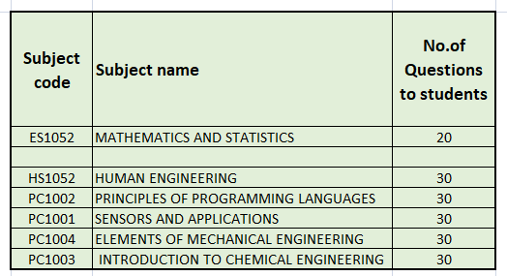
9. Exam duration for each subject is 1 hour and 30 minutes. First 10 minutes to join and to give attendance and remaining 1 hr 20 minutes for MCQ exam on VIERP.
In case of any malpractice, students will get punishment as per institute policy.
In case any query does not reply to this mail, you can ask your queries to subject teachers. In case of any issue during the exam, contact the subject teacher only. (Exam will be conducted, monitored and proctored by subject teacher only)

Dummy online exams are scheduled on 28th March 2024.

1. Dummy exam is not a practice test for any subject.
2. Purpose of the dummy exam is to ensure whether a student is correctly registered for all subjects and to get acquainted with Quiz software. It contains random general knowledge questions.
3. Duration of the dummy exam is 15 minutes.

Examination section

