ISA intro meet and engineer’s day celebration
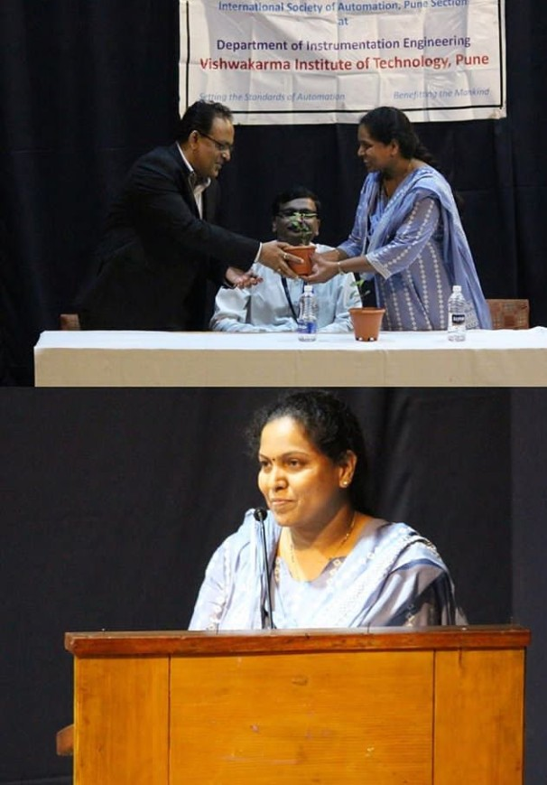
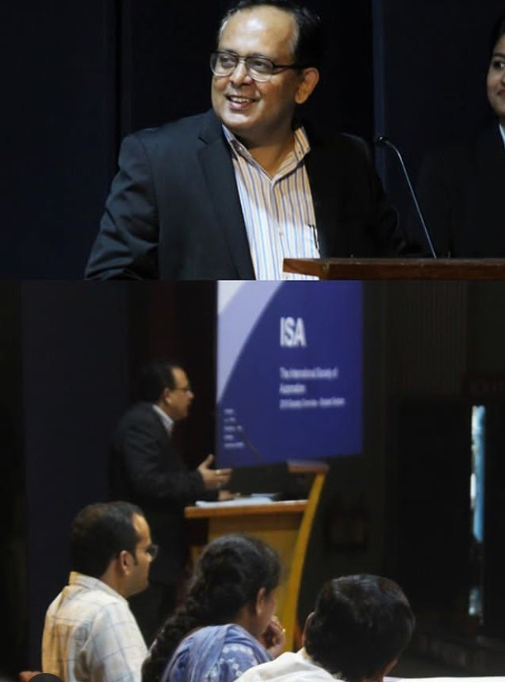
On 18th September 2019, the department of Instrumentation and control engineering conducted an intro meet of the ISA VIT Pune chapter. It was followed by celebration of Engineer’s day in Sharad arena. ISA VIT Pune chapter is a students’ section which runs under the International society of automation. It is a technical society for engineers , technicians and students who study or work in the field of industrial automation.

Engineer’s day is celebrated every year to commemorate the birthday of one of the greatest engineers in India, Sir Mokshagundam Visvesvaraya. To grace this occasion, we invited Mr. Abhay Bansod and Mr. Vinod Joshi as our chief guests. Mr. Bansod is the Director of Emerson Automation Solution, EEEC Pune. He shared his own career path with us to explain the need of exploring till one finds his true interest. He mentioned one of his friend’s life changing experience , about how an average student who faced enormous obstacles in his life, went on to become a very successful person in his career. Patience, determination and learning from your failures can take you to great places. He encouraged us to learn more and develop at least one hobby.
He certainly left all of us inspired at the end of his speech. With his simple words, he taught us to never stop trying and learn from your failures as it is just a first attempt in learning.
Our next chief guest, Mr. Joshi is an active member of the International Society of Automation. He briefed the audience about the benefits of being an ISA member.
ISA also conducted an elocution competition for the students of our department. The students had to choose any of the topics given to them and express their views. The winners were felicitated by our honorable chief guests. Participation certificates were given to all the participants.
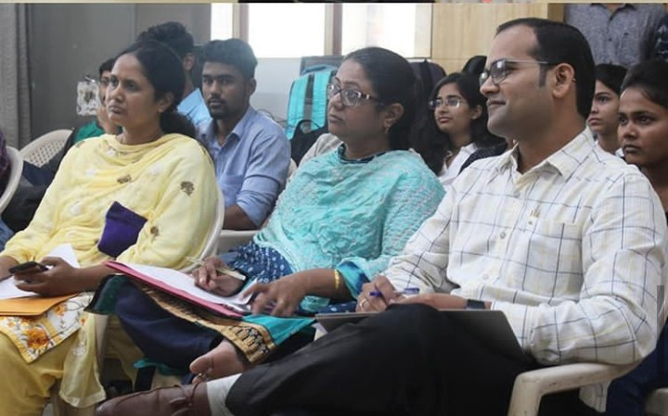
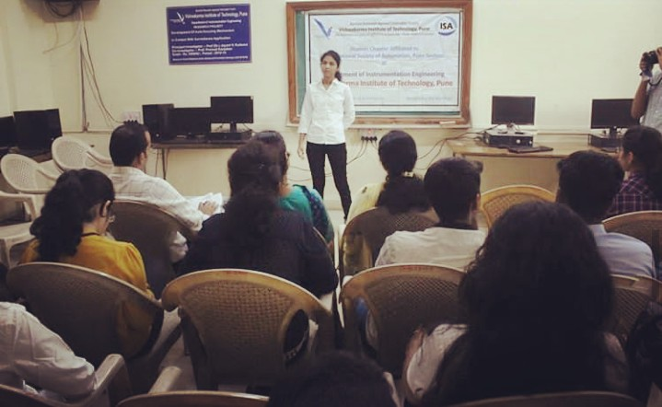
With great enthusiasm and participation from the students and members of ISA, this event turned out to be a huge success. At the end of the day we felt great sense of pride that we were pursuing engineering. It definitely inspired us to take steps and work for the betterment of our society.
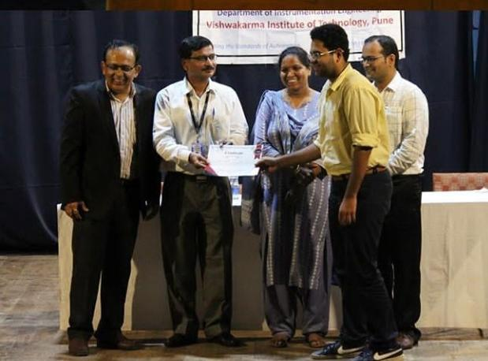

As Elon Musk once said,
Engineering is the closest thing to magic that the world has.
This day made us confident that with our efforts, we can make magic happen!
“I organise the efforts and skills of my fellow workers employing the capital of the thrifty and the products of many industries, and together we work toward our goal undaunted by hazards and obstacles.
And when we have completed our task all can see that the dreams and plans have materialised for the comfort and welfare of all.
I am an Engineer, I serve mankind, by making dreams come true.”

