Three-Day Faculty Development Program on Universal Human Values (UHV)
6th – 8th April 2026
Organised by
Department of Engineering Sciences and Humanities (DESH)
Vishwakarma Institute of Technology, Pune – 411037
In association with
NCC-IP, AICTE, New Delhi

About NCC-IP
The National Coordination Committee for Student Induction Program (NCC-IP) is an initiative of AICTE that conducts Faculty Development Programs (FDPs) on Universal Human Values (UHV). These programs aim to prepare faculty members for effectively delivering the Student Induction Program (SIP) and fostering value-based education among students.

About Vishwakarma Institute of Technology, Pune
Vishwakarma Institute of Technology (VIT), Pune is a reputed private autonomous institute in the western region of India. Established in 1983, the institute is affiliated with Savitribai Phule Pune University and is known for its commitment to academic excellence and holistic development.

Department of Engineering Sciences and Humanities (DESH)
The Department of Engineering Sciences and Humanities plays a vital role in imparting humanities and foundational subjects across all engineering disciplines. In alignment with AICTE guidelines and NEP 2020, the department emphasizes a holistic approach to teaching and learning.
As part of this vision, DESH, in association with NCC-IP and AICTE, organized a three-day Introductory FDP on Universal Human Values (UHV).
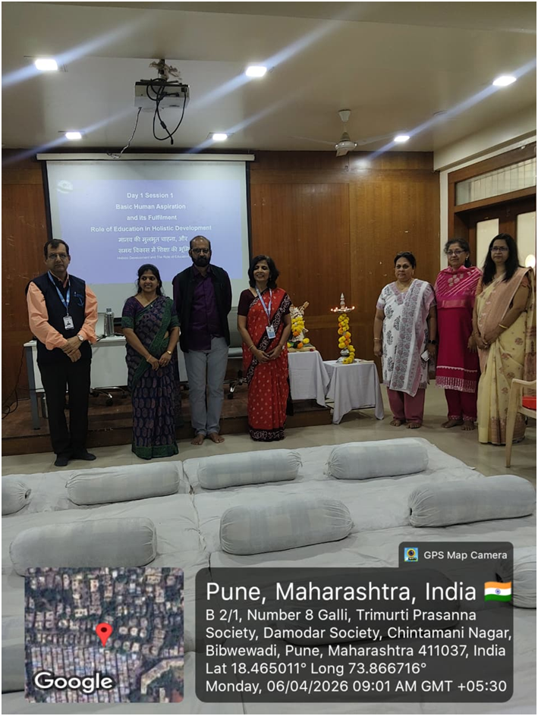

About the FDP
The Faculty Development Program on Universal Human Values is designed to help participants understand and integrate human values into their personal and professional lives. The program focuses on:
- Promoting ethics and moral values
- Building a cohesive and harmonious society
- Contributing to global peace and sustainability
- Encouraging personal growth and self-development
- Addressing contemporary societal challenges
- Ensuring harmony at the levels of individual, family, society, and nature

The FDP is conducted through a structured process of self-inquiry and self-verification, enabling participants to develop self-confidence, clarity, and a deeper understanding of life and relationships.
The program received an overwhelming response, with 70 participants actively attending the sessions.
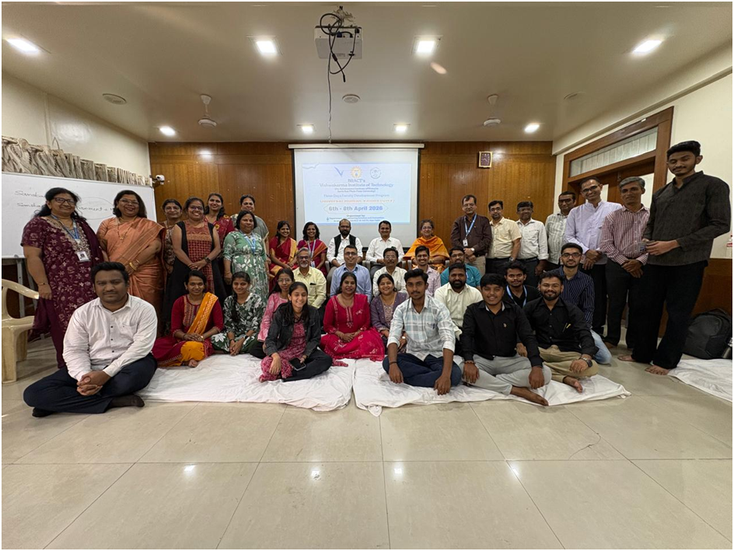

Resource Team (NCC-IP, AICTE)
- Resource Person: Shri Vinay Chidri
Advisor, Centre of Universal Human Values, Maharashtra Institute of Technology, Chhatrapati Sambhajinagar
- Co-Facilitator: Ms. Archana Mirashi
- Observer: Ms. Sakshi M. Hosamani
- Regional Coordinators (Western Region, NCC-IP AICTE):
  - Dr. Mohan B. Rao
  - Prof. Aprajita Singh
  - Dr. Anita S. Mane

Chief Patrons
- Shri Rajkumar Agarwal – Chairman, BRACT, Pune
- Shri Bajrangdas Lohiya – Vice Chairman, BRACT, Pune
- Shri Bharat Agarwal – Managing Trustee, BRACT, Pune
- Dr. Bipin Sule – CEO, Vishwakarma Group
- Prof. (Dr.) Rajesh Jalnekar – Director, VIT Pune

Convener
- Dr. Shilpa Lambor (Head, DESH)

Local Coordinators
- Dr. Varsha Karandikar
- Prof. Vivek Nagnath

