

DEPARTMENT OF COMPUTER SCIENCE & ENGINEERING (ARTIFICIAL INTELLIGENCE & MACHINE LEARNING)
CSE(AI&ML)- SPECTRUM
JANUARY - 2026

Generative AI and Autonomous AI Agents
Welcome to the edition of the CSE(AIML)-Spectrum focused on Generative AI and Autonomous AI Agents .
This edition explores how modern AI systems are moving beyond analysis to creation and independent action. Generative AI enables machines to produce original text, images, code, and media, while Autonomous AI Agents extend these capabilities by planning, deciding, and executing tasks with minimal human intervention. Together, these technologies are reshaping software development, cybersecurity, automation, and decision-making across industries. This bulletin provides an overview of the concepts, evolution, and working principles behind these transformative AI systems.

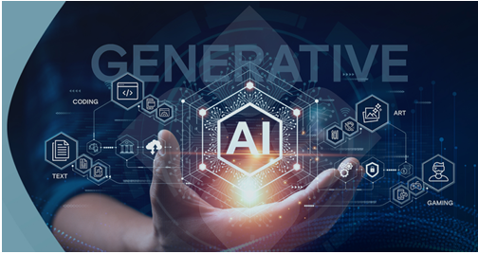

1.INTRODUCTION
Generative AI focuses on creating new content by learning patterns from existing data. Unlike traditional AI systems that follow predefined rules, Generative AI produces original outputs such as text, images, and code based on context and probability. Autonomous AI Agents build on this foundation by using Generative AI to reason, plan, and act independently. These agents can analyze information, make decisions, and adapt to changing environments, enabling higher levels of automation and efficiency in real-world applications.
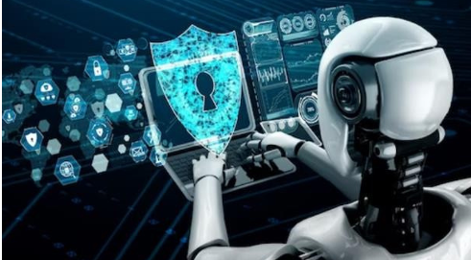
Early artificial intelligence systems were primarily based on rule driven logic, where developers explicitly defined instructions and conditions for every possible scenario. As computing power increased, advancements in machine learning and deep learning enabled AI systems to learn patterns directly from large datasets rather than relying solely on predefined rules. This shift led to the development of Generative AI models, which introduced the ability to create new content instead of only analyzing or classifying existing data. More recently, these capabilities have evolved into Autonomous AI Agents that integrate reasoning, memory, and tool usage, allowing them to perform complex, multi-step tasks with minimal human supervision.

2.HOW GENERATIVE AI WORKS
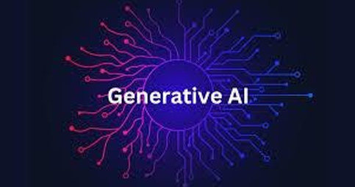
How Generative AI Works — Models, Learning, and Creativity Generative AI systems are built using neural network models trained on vast amounts of data, enabling them to learn relationships between text, images, and other forms of information. These deep learning models capture complex patterns and structures present in the data and continuously improve by adjusting internal parameters during the training process to minimize errors. Creativity in Generative AI emerges through probabilistic prediction, where the system generates outputs by selecting the most likely next element while introducing controlled randomness to ensure originality. When a user provides a prompt, the model analyzes the context and produces a response based on learned patterns. Although Generative AI does not possess true understanding or consciousness, it delivers fast, scalable, and creative outputs that make it a powerful tool in modern technology.
From Chatbots to AI Agents Traditional chatbots are designed to respond to user queries using predefined rules or trained language models. These systems are reactive, meaning they generate responses only when prompted and operate within a limited conversational scope. Most chatbots do not retain long-term memory, cannot interact with external systems independently, and lack decision-making capabilities beyond text generation. AI agents represent a more advanced form of artificial intelligence. An AI agent is capable of perceiving its environment, making decisions, and executing actions to achieve specific objectives. Unlike chatbots, AI agents can operate autonomously, maintain contextual memory, and interact with external tools such as databases, APIs, and software services. From a technical perspective, chatbots usually rely on a single inference model, while AI agents integrate multiple components including reasoning modules, memory management, and action planning mechanisms. AI agents can decompose complex tasks into smaller steps and execute them sequentially, enabling automation of workflows rather than simple conversation. In essence, chatbots focus on user interaction, whereas AI agents focus on goal-oriented task execution, making them suitable for automation and intelligent systems.
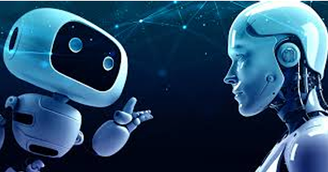
3.Applications of Generative AI in Education and Research
Generative AI is used in education as a support tool to enhance learning and academic productivity. It assists students by generating summaries, explanations, and practice material, helping improve understanding of complex topics. In technical subjects, it can support basic code generation, error identification, and concept clarification. In research, generative AI aids in literature analysis, data summarization, and documentation drafting. Researchers use it to process large volumes of information efficiently. However, AI-generated outputs may contain inaccuracies, making human verification essential. Generative AI complements learning and research but does not replace critical thinking or academic responsibility.
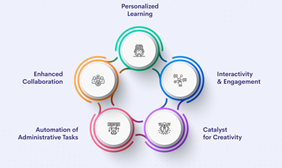
AI agents are applied in industry to improve automation and operational efficiency. They can monitor systems, analyze data, and perform predefined actions with minimal human intervention. In manufacturing and IT environments, AI agents support tasks such as predictive maintenance, fault detection, and system monitoring. In business workflows, AI agents automate routine processes like data retrieval, report generation, and process coordination across systems. These agents operate within defined limits and are deployed with human oversight to ensure reliability and control. AI agents primarily function as assistive automation tools, enhancing productivity rather than replacing human decision-making.

4.Opportunities for Students
Skills and Career Pathways Introduction Artificial Intelligence is rapidly transforming education and career options for students. Today’s generation has access to tools and technologies that can shape innovative and future ready careers. Key Opportunities Students can develop skills in AI, data science, machine learning, prompt engineering, and automation. AI also supports careers in content creation, design, marketing, finance, healthcare, and research. With the right skills, students can explore roles such as AI developer, data analyst, digital strategist, and technology consultant. Career Impact Learning AI improves problem-solving, creativity, and employability. Early exposure helps students adapt to future job markets and stay ahead in a competitive world.

5.Ethical Use of AI
Privacy, Bias, and Academic Integrity Introduction As AI becomes more powerful, ethical responsibility becomes essential. Using AI correctly ensures trust, fairness, and respect for individual rights. Privacy and Bias AI systems rely on data, making data privacy a major concern. Improper data handling can lead to security risks. Bias in AI can occur due to unbalanced data, affecting fairness in outcomes. Academic Integrity Students should use AI as a learning tool, not a shortcut for plagiarism or cheating. Ethical usage promotes honesty, originality, and responsible learning.

6.Challenges and Risks
Deepfakes, Misinformation, and Misuse Introduction Despite its advantages, AI also presents serious challenges that must be addressed carefully. Major Risks Deepfakes can manipulate videos and images, spreading false information. AI-generated misinformation can influence opinions and damage credibility. Misuse of AI in cybercrime and fraud is another growing concern. Need for Awareness Students must develop critical thinking skills and digital literacy to identify and counter AI-related risks.


7.Future of Intelligence
Humans and AI Working Together Introduction The future of intelligence lies in collaboration, not competition, between humans and AI. Human–AI Partnership AI excels at speed, accuracy, and data processing, while humans contribute creativity, empathy, ethics, and judgment. Together, they can achieve better outcomes. Looking Ahead This collaboration will drive progress in education, healthcare, innovation, and sustainability, creating a future where technology enhances human potential.

8.References
Books
Goodfellow, I., Bengio, Y., & Courville, A. (2016). Deep Learning. MIT Press. Russell, S. J., & Norvig, P. (2021). Artificial Intelligence: A Modern Approach (4th ed.). Pearson. Sutton, R. S., & Barto, A. G. (2018). Reinforcement Learning: An Introduction (2nd ed.). MIT Press. 🔹 Foundational Research Papers – Generative AI Goodfellow, I., et al. (2014). Generative Adversarial Nets. Advances in Neural Information Processing Systems (NeurIPS). Kingma, D. P., & Welling, M. (2014). Auto-Encoding Variational Bayes. International Conference on Learning Representations (ICLR). Vaswani, A., et al. (2017). Attention Is All You Need. Advances in Neural Information Processing Systems (NeurIPS). Brown, T. B., et al. (2020). Language Models are Few-Shot Learners. NeurIPS. Ho, J., Jain, A., & Abbeel, P. (2020). Denoising Diffusion Probabilistic Models. NeurIPS. 🔹 Autonomous AI Agents & Multi-Agent Systems Wooldridge, M. (2009). An Introduction to MultiAgent Systems. Wiley. Shoham, Y., & Leyton-Brown, K. (2008). Multiagent Systems: Algorithmic, Game-Theoretic, and Logical Foundations. Cambridge University Press. Silver, D., et al. (2016). Mastering the Game of Go with Deep Neural Networks and Tree Search. Nature. Mnih, V., et al. (2015). Human-level Control through Deep Reinforcement Learning. Nature. 🔹 Recent Surveys & Industry Perspectives Bommasani, R., et al. (2021). On the Opportunities and Risks of Foundation Models. Stanford CRFM. Park, J. S., et al. (2023).

STUDENT EDITORS



Aditya Patil Mrudula Kotgire Adish Nair
SY E(CSE(AIML) SY D(CSE(AIML) SY D(CSE(AIML)

