December 2025

AIML-VISHWA
CSE(AI&ML) Volume 1

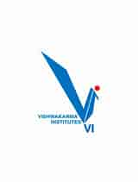 CONTENTS

ABOUT INSTITUTE

VIT Pune is the leader in academic excellence, promoting an interactive and participative learning process. It has a reputation of being innovative, research-oriented and committed.The institute keeps on influencing the future, holistic development. scholars of different disciplines.With state-of-the-art infrastructure, laboratories and a robust. focus on practical studies, VIT Pune provides students with. relevant education that is rigorous and demanding. of the global workforce.
Our faculty are diverse, and committed to us,campus life, colorful student body, and ecosystem is formeda cquiring which is an accompaniment of academic pursuits,co-curricular activities, which promote self-development and leadership. VIT Pune will always be there as we aim at excellence. dedicated to the creation of non-only people. proficiently skilled technically and socially responsible and prepared to. mean something to the society and the world.

DELL
CSE(AI&ML) ,VIT,PUNE
ABOUT DEPARTMENT-CSE(AI&ML)

The CSE–AIML Department at VIT Pune stands as a center of excellence dedicated to innovation, research, and advanced technological learning. The department is committed to cultivating a strong academic foundation while preparing students to excel in the rapidly evolving domains of Artificial Intelligence, Machine Learning, Data Science, and Intelligent Computing. With a curriculum that blends rigorous theoretical knowledge with practical, hands-on experience, the CSE–AIML department ensures that students gain a deep understanding of modern computational techniques and AI-driven technologies. Through cutting-edge laboratories, industry-focused programs, interdisciplinary projects, and emerging research opportunities, students are encouraged to explore, experiment, and innovate.
Our highly accomplished faculty, state-of-the-art infrastructure, and collaborative initiatives with industry and research organizations create an environment that nurtures curiosity, critical thinking, and problem-solving ability. We take immense pride in our students’ achievements across academic pursuits, competitive platforms, internships, and entrepreneurial ventures.
The department remains steadfast in its mission to develop technologically proficient, ethically responsible, and future-ready professionals who will lead the next wave of AI-driven transformation in society and industry.

FROM THE HOD’s DESK
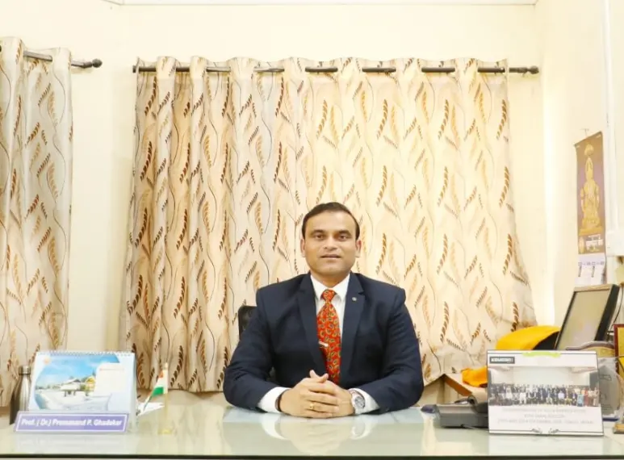
Department of Computer Science & Engineering (AI & ML) at VIT Pune—a dynamic and forward looking program established in 2022 designed to empower tomorrow’s innovators. We pride ourselves on a state of the art learning environment, including cutting-edge laboratories, hardware accelerators, and industry-grade software tools that enrich both academic and research pursuits.
CSE (AI & ML) department thrives on excellence—our students have brought laurels by securing top positions in hackathons, reflecting their technical depth and creative problem-solving skills. Beyond competitions, they are building impactful solutions through capstone projects, research projects, and internships that drive real-world impact. Faculty members, with diverse expertise in Computer Engineering core subjects, ML, AI, deep learning, blockchain, Gen AI and cloud computing, maintain active engagement through research publications, guest lectures, and workshops .

Student Internship’s

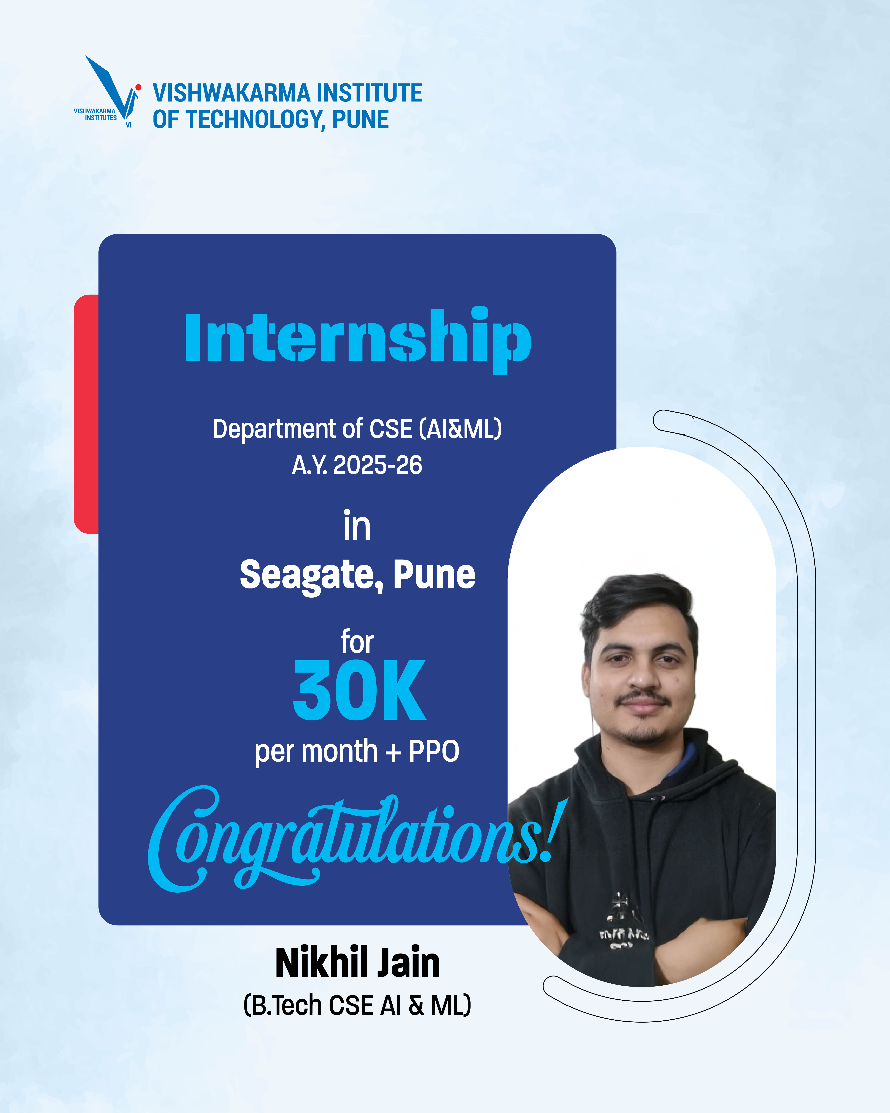
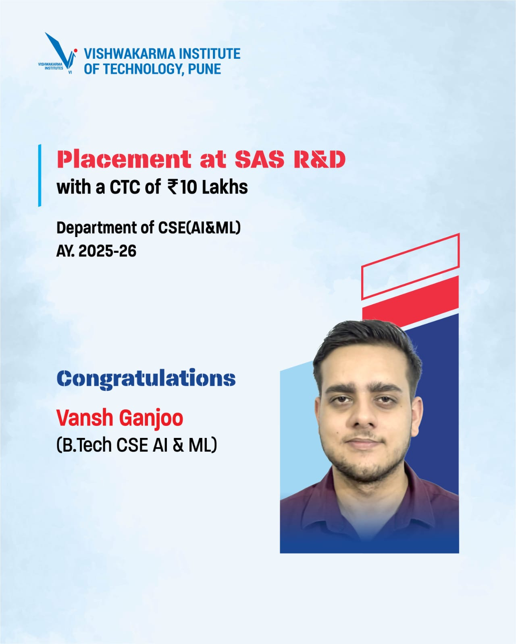
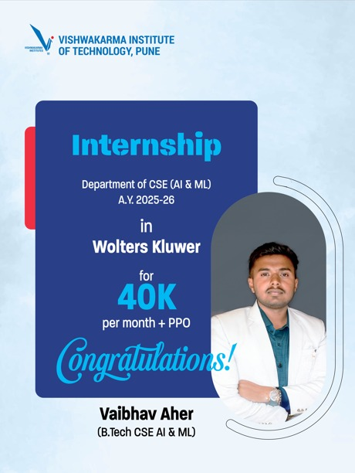
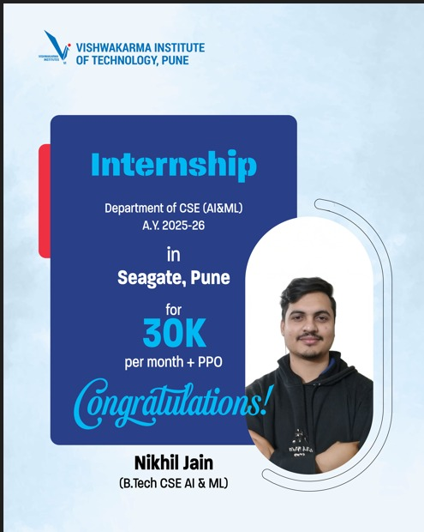
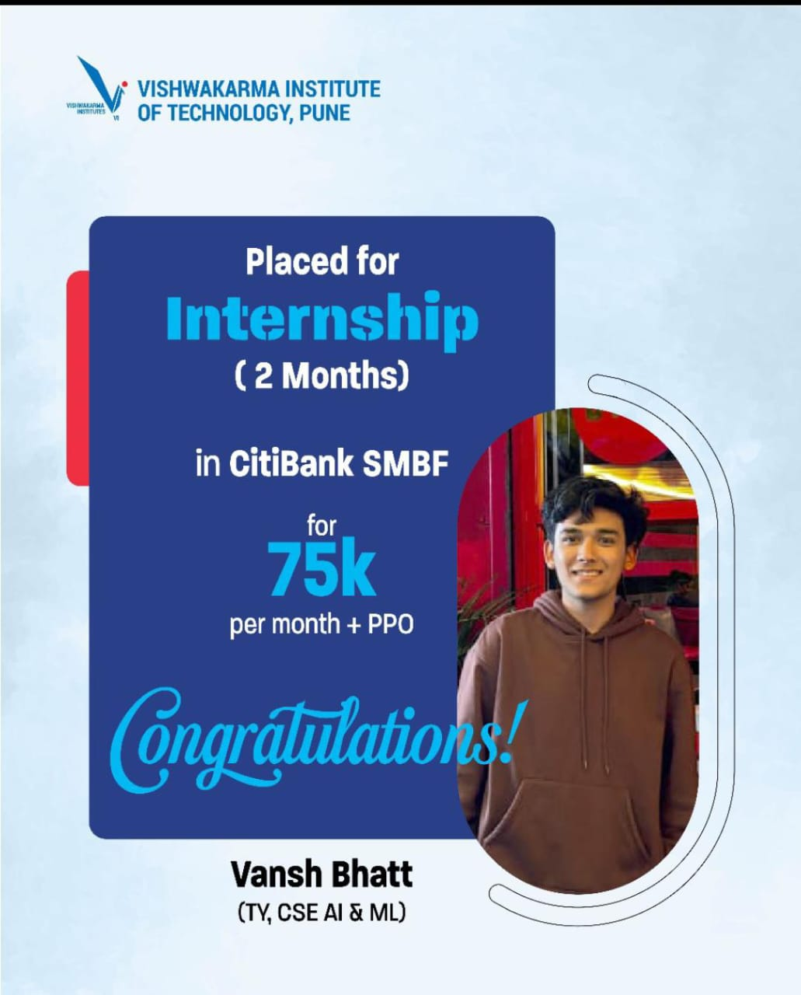
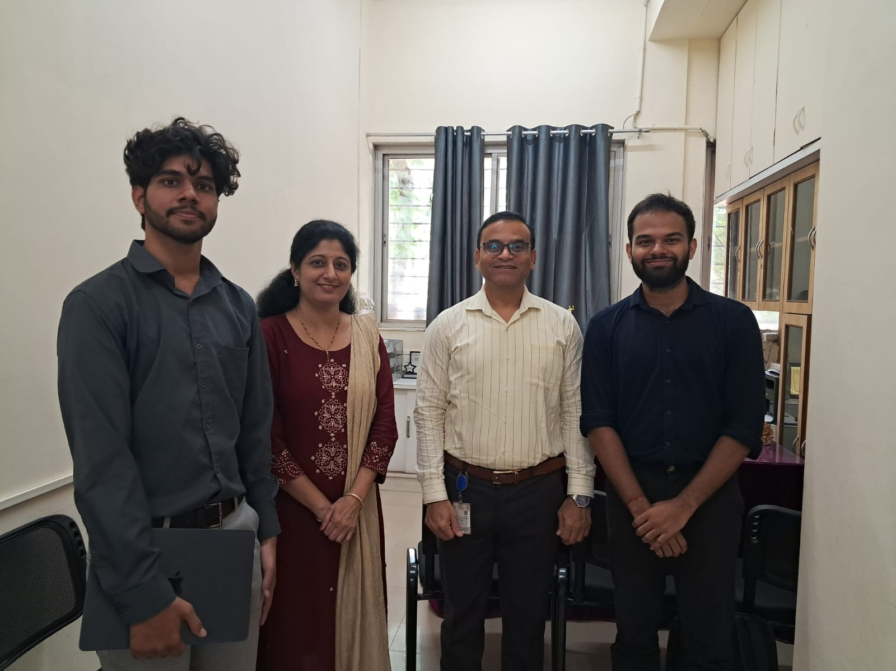

Congratulation to Devashish Kanhere, Finsl year CSE-AI&ML for the selection in BlackRock (Mumbai) for internship. 💐💐
Role :- Aladdin Data Intern( stipend:-50000 , ppo :-18lpa)
Internship Duration:- 6 Months.

Student Club Activities

VODAFONE FULL STACK DEVELOPMENT WORKSHOP

Dates:- 28July 2025-1 Aug 2025 (5 Days)
Coordinators:- Dr. Premanand Ghadekar
Organizing Team:- Dr.Amruta Amune & Ravishankar Bhaganagare

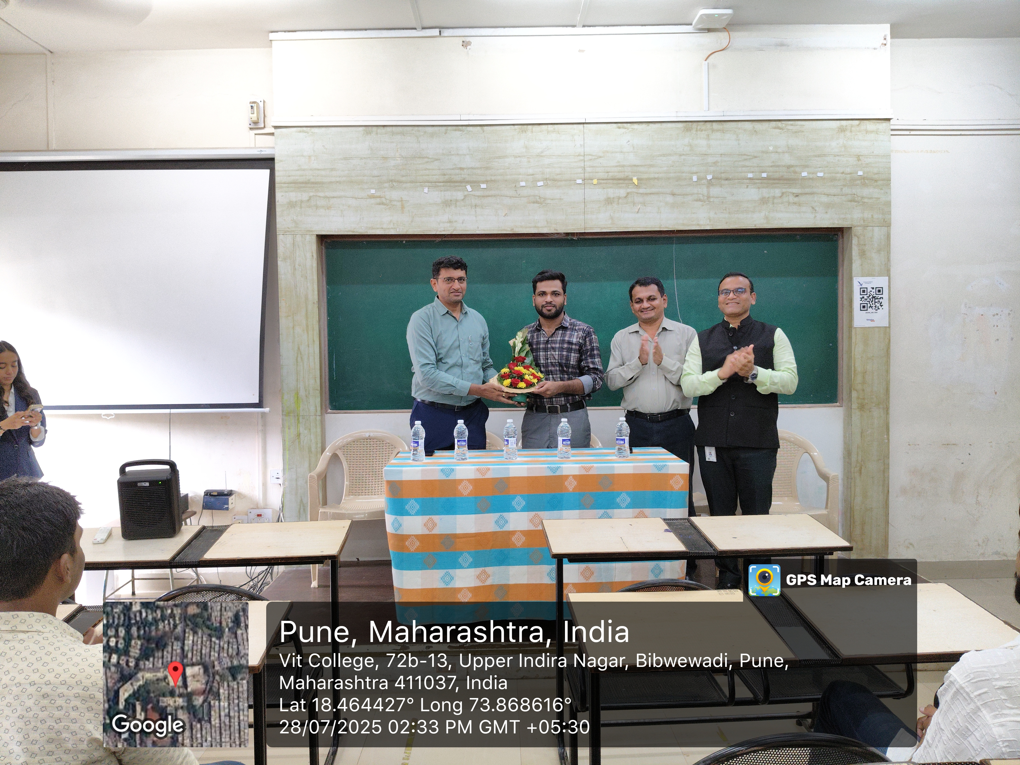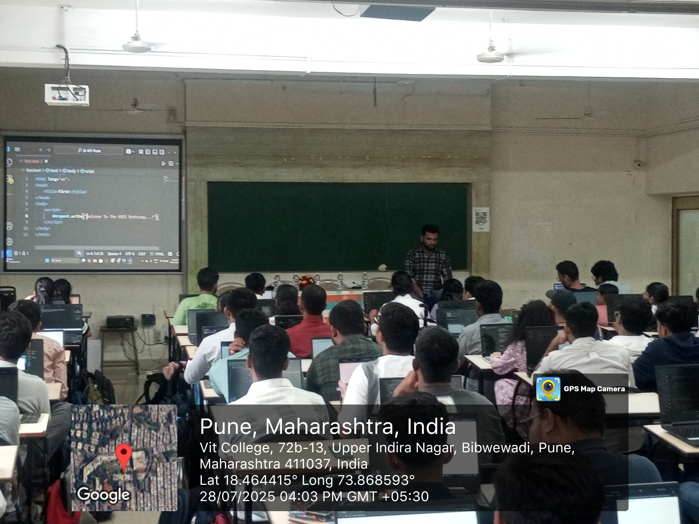

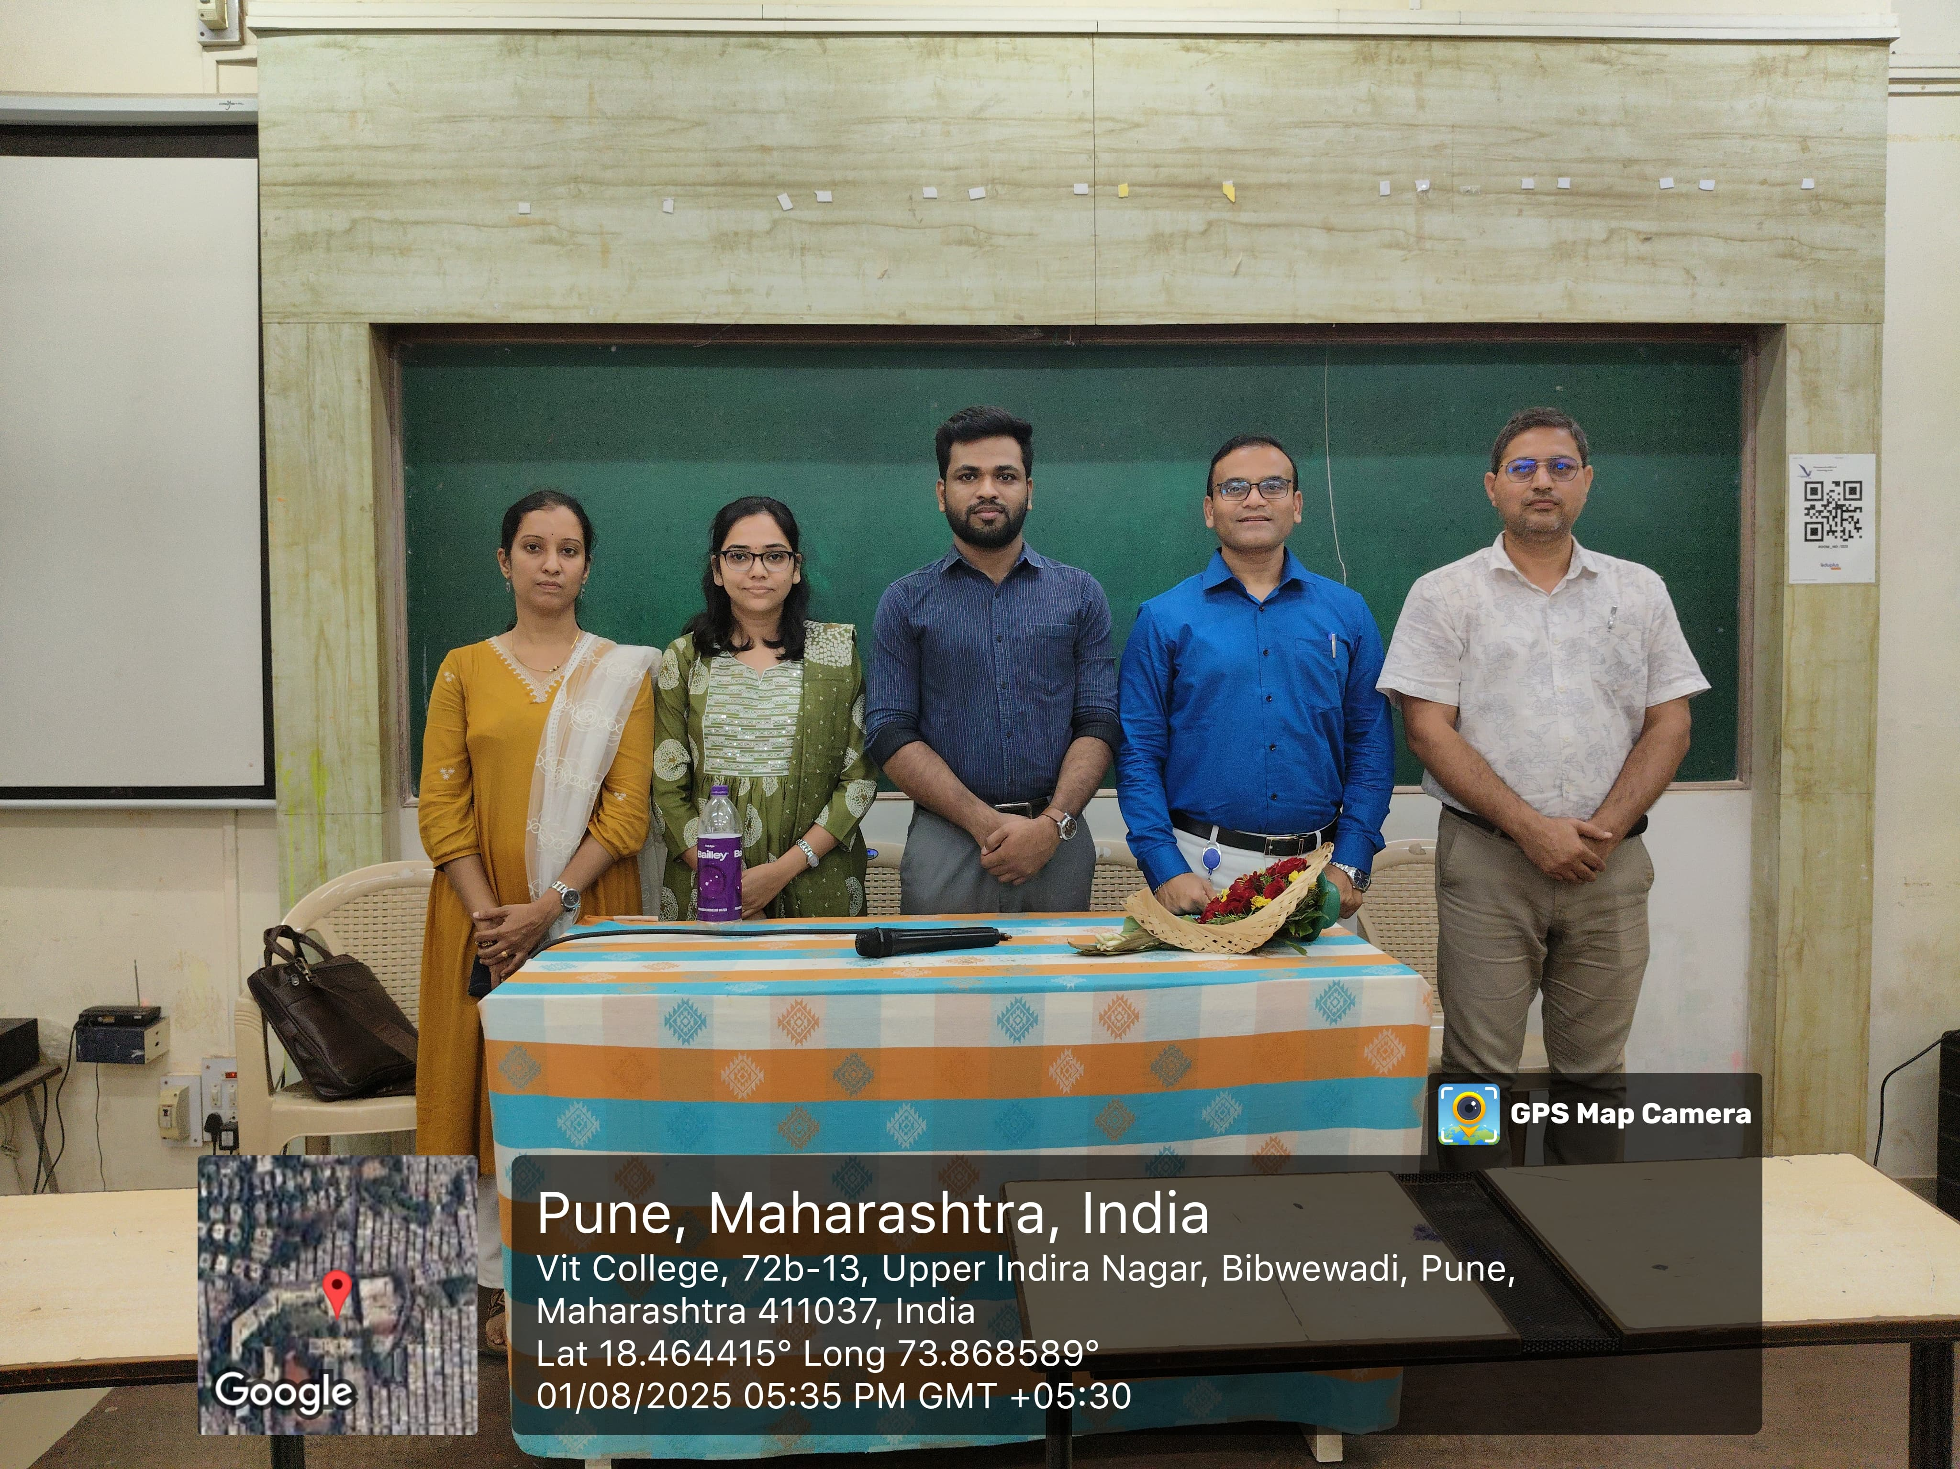

Summary
A five-day Full Stack Development Workshop (28th July – 1st August
2025) was conducted by the Department of CSE (AI &amp; ML), VIT Pune, in
collaboration with Vodafone Company. The sessions focused on
frontend, backend, database integration, and cloud deployment, along
with career insights from industry experts. The workshop provided
hands-on exposure to students, bridging the gap between academic
learning and industry practices. Over 250 students benefited, gaining
practical skills in end-to-end application development and enhancing
their employability and career readiness.

Title:- Cyber Security and Ethical Hacking Workshop
Dates:- 4th August – 8th August 2025 (5 Days)
Coordinators:- Dr. Premanand Ghadekar
Invited Speakers: - Mr. Vignesh Mathiyalagan
Industry name- Vodafone Company

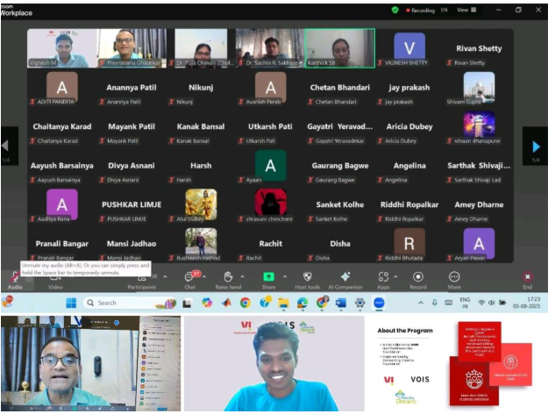

Summary
A five-day online workshop on Cyber Security and Ethical Hacking (4th – 8th August 2025) was organized by the Department of CSE (AI & ML), VIT Pune, in collaboration with Vodafone VOIS. The sessions covered cybersecurity fundamentals, ethical hacking basics, penetration testing, vulnerability analysis, and real-time case studies. Over 250 students participated, gaining practical insights into identifying and mitigating cyber threats. The workshop enhanced students’ awareness, technical skills, and career readiness in the field of cybersecurity.
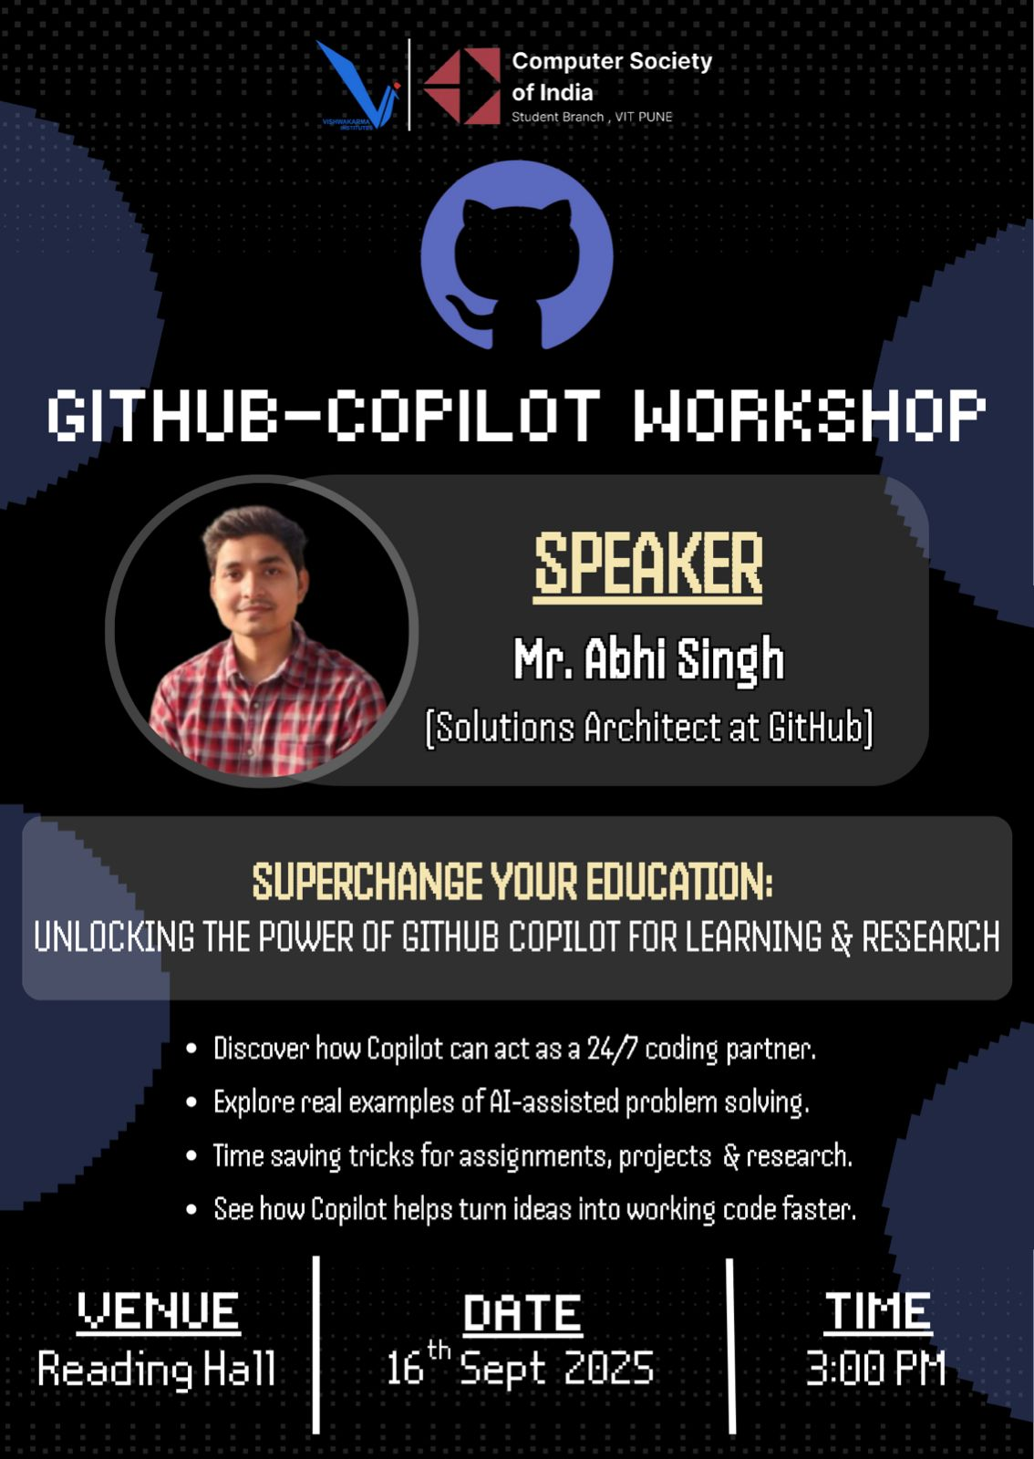
Title:- GITHUB COPILOT Workshop
Dates:- 4th August – 8th August 2025 (5 Days)
Coordinators:- Dr. Premanand Ghadekar
Invited Speakers: - Mr. Abhi Singh
Industry name- Github
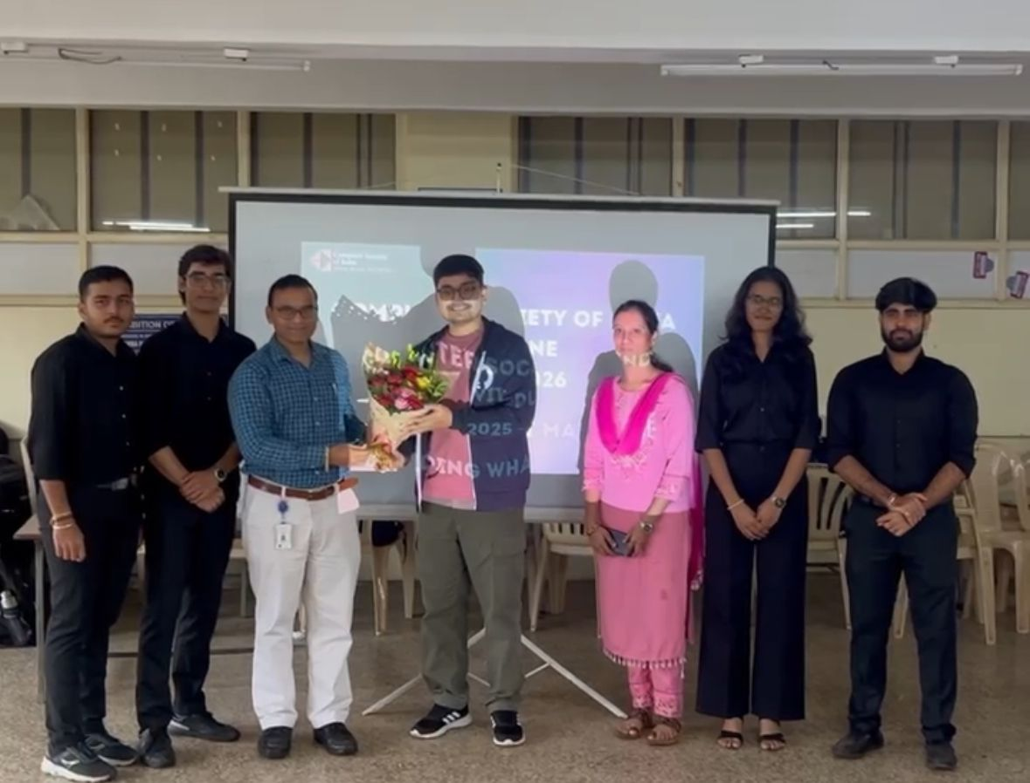
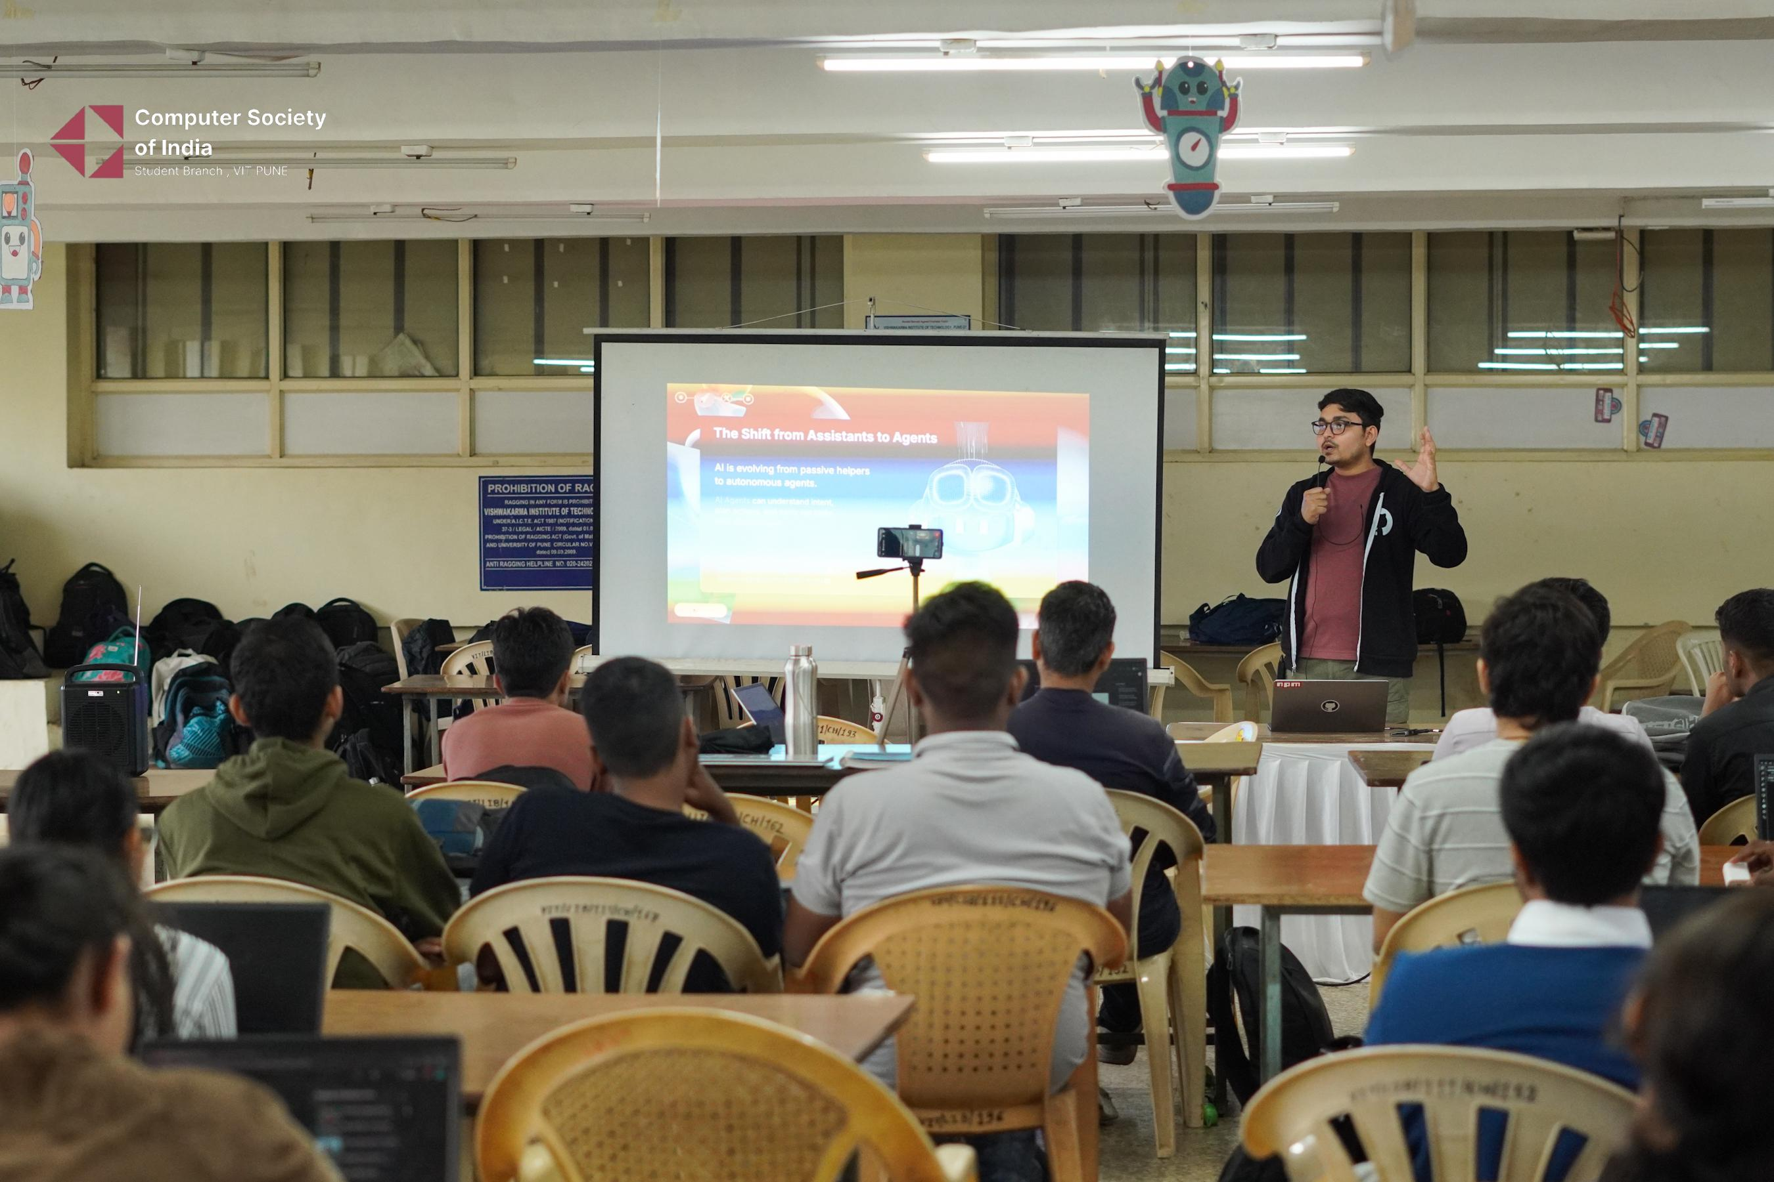
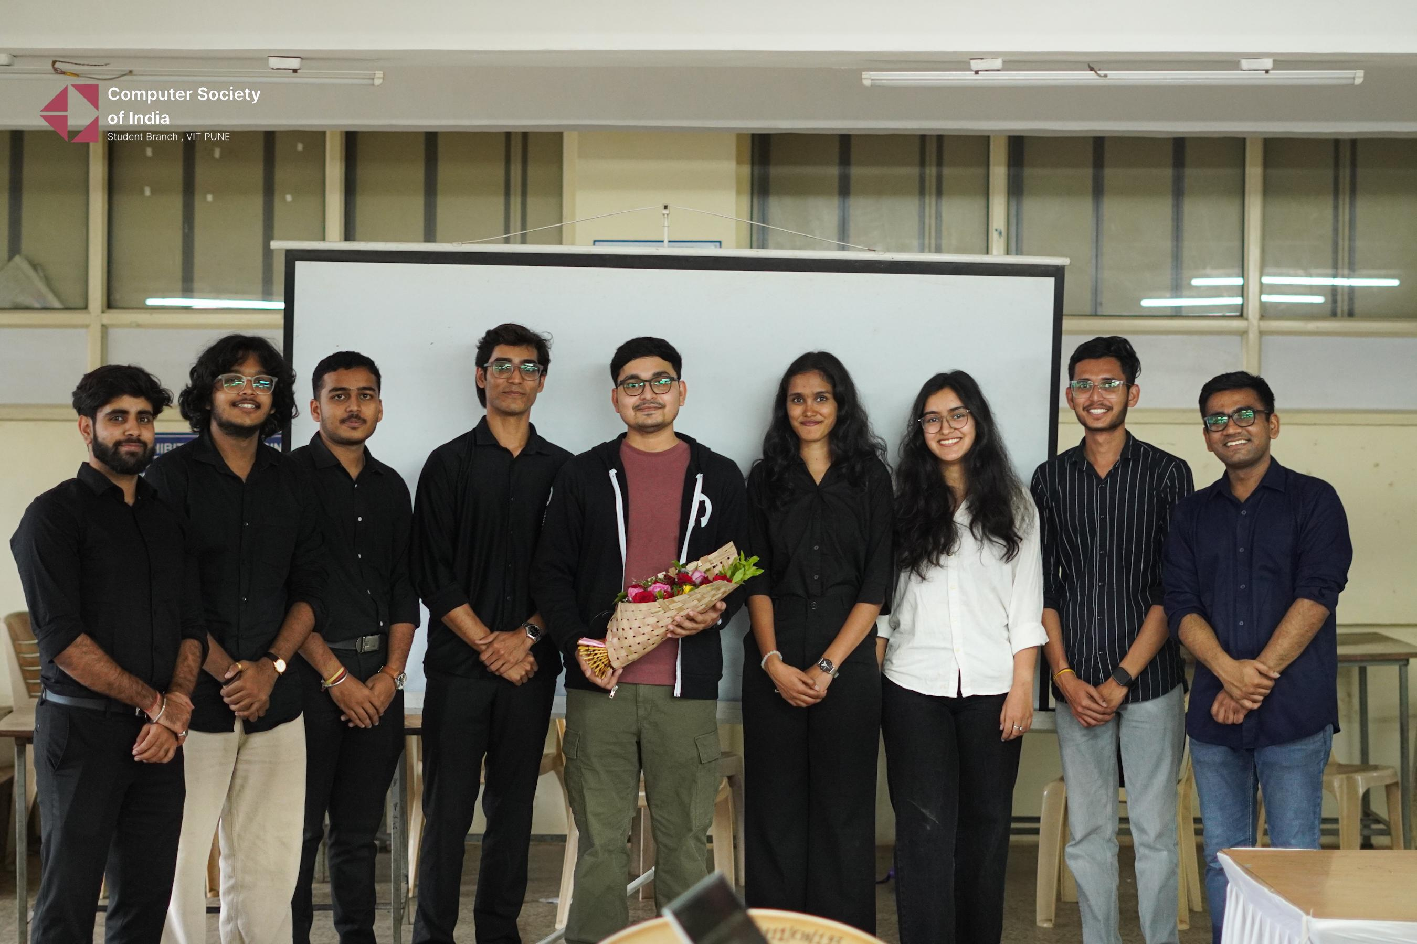
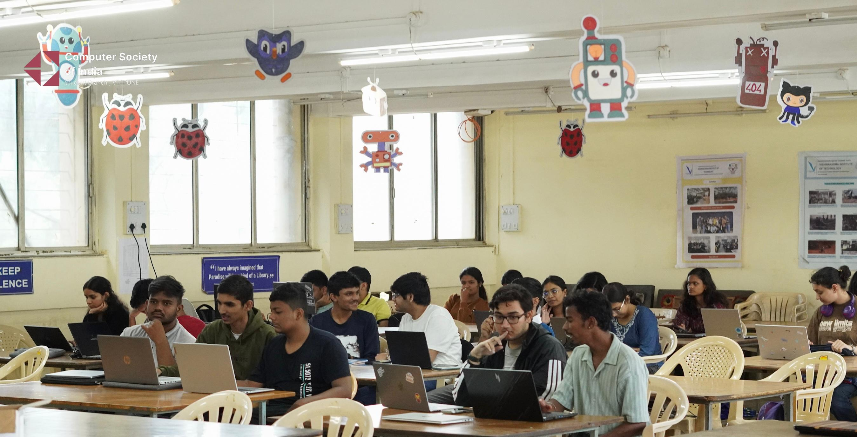

Summary
A online workshop on Github(16th September 2025 at 3.00pm) was organized by the Department of CSE (AI & ML), VIT Pune. The session was delivered by Mr.Abhi Singh(Github) based on Github fundamentals, Copilot basics, how ot act as 24/7 asisstant for problem solving,assignment ,projects and research.

Industrial Visit to MITCON Consultancy & Engineering Services Ltd., Pune
Date: 16 October 2025 Time:2:30 pm to 5:30pm
Faculty Coordinators:
Dr. Premanand P. Ghadekar, Head, Department of CSE (AI & ML)
Dr. Amruta Amune, Department of CSE (AI & ML)
Prof. Ravishankar Bhaganagare Department of CSE (AI & ML)
Prof. Ashlesha Sawant, Department of CSE (AI & ML)

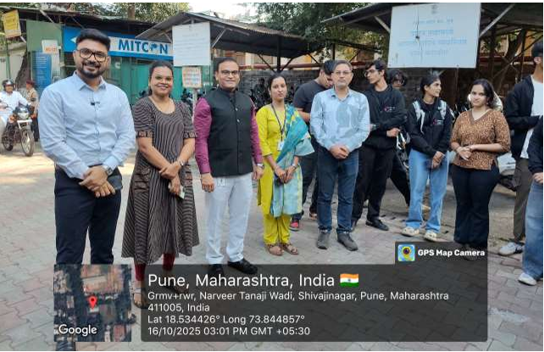
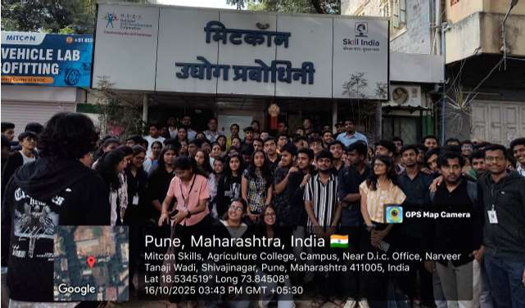

Summary
The Department of Computer Science and Engineering (AI & ML), Vishwakarma Institute of Technology, Pune, organized a one-day industrial visit to MITCON Consultancy & Engineering Services Ltd., Pune on 14 October 2025 from 3:00 p.m. to 6:00 p.m. A total of 150 students from the CSE (AI & ML) Department participated in the visit, accompanied by four faculty members. The session was highly interactive, featuring discussions on the integration of Artificial Intelligence and Machine Learning in industrial and consultancy applications.

Student Achievements

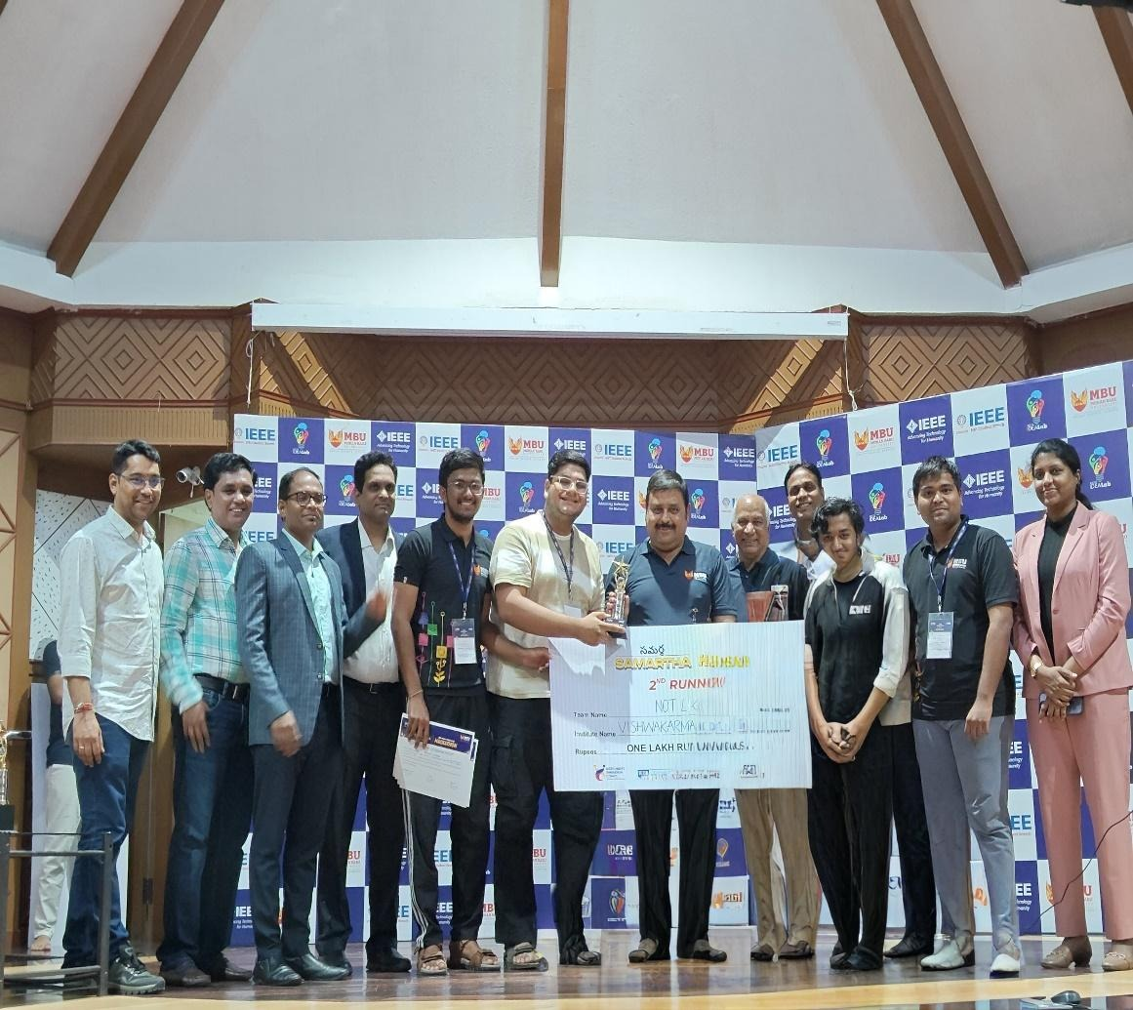

Date-27/10/2025

Award/Winner-2nd Runner Up prize at Samarth Hackathon Finale in MBU Tirupati
Event - Samarth Hackathon Finale in MBU Tirupati

Prize- 1lakh cash prize+ trophy+ certificate
Opportunity-Project
Student Name-
Atharva Patwardhan (Team leader) - TY AIML B
Atharv Muchandi - TY AIML A, Ayush Srivastava -TY AIML B,
Shreeram Ujlambkar- SY AIML

Name of Applicant Atharv Patwardhan
Name of Competition Young Innovators Award 2025
Date of Competition 28th November 2025
Award/Rank Shortlisted in Top 5 Teams (All India Level)
Prize / Amount Received
Team Member Names Year (FY/SY/TY/FINAL YR) Department
1) Atharva Patwardhan TY CSE (AIML)
2) Atharv Muchandi TY CSE (AIML)
3) Vishruti Mohinkar TY CSE (AIML)
4) Vedant Nagmoti TY CSE (AIML)

Summary
The Young Innovators Award 2025 recognizes outstanding student innovations across India in healthcare and technology. Our team was selected among the Top 5 innovations nationally topresent at the InnoHEALTH Conference 2025 hosted at Artemis Hospital, Gurugram. The selection was based on novelty, feasibility, and social impact of the proposed solution. The final presentation and award ceremony will take place on 28th November 2025.

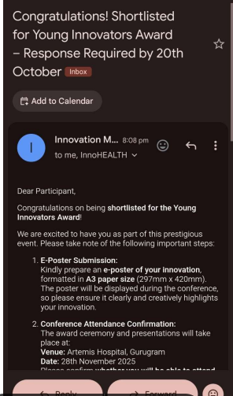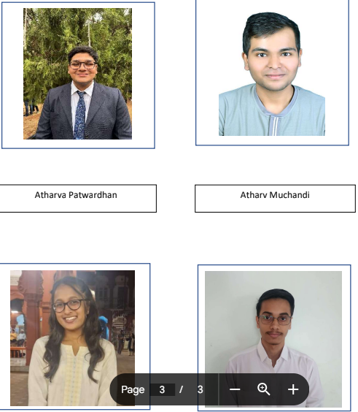
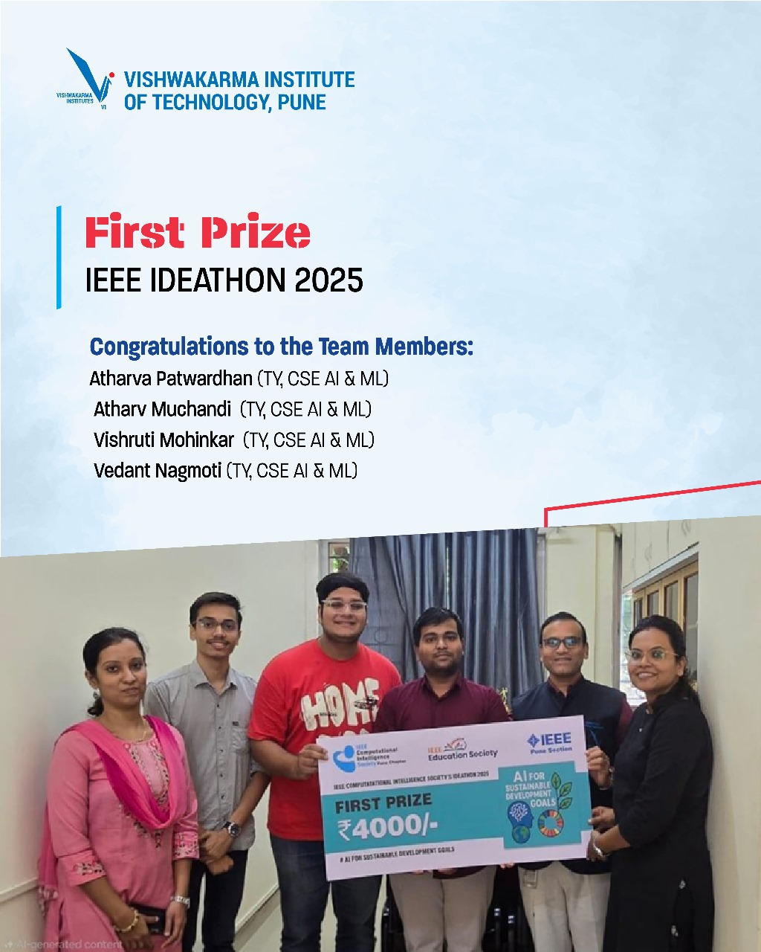
Name of Applicant | Atharva Patwardhan
Name of Competition | IEEE IDEATHON 2025
Date of Competition | 22th Aug
Award/Rank | 1st Price
Prize / Amount Received | ₹4,000 + Certificates
Opportunity
( Placement, internship, Project, Funding etc..)
Team Member Names | Year (FY/SY/TY/FINAL YR) | Department
1) Atharva Patwardhan | TY | CSE (AIML)
2) Atharv Muchandi | TY | CSE (AIML)
3) Vishruti Mohinkar | TY | CSE (AIML)
4) Vedant Nagmoti | TY | CSE (AIML)

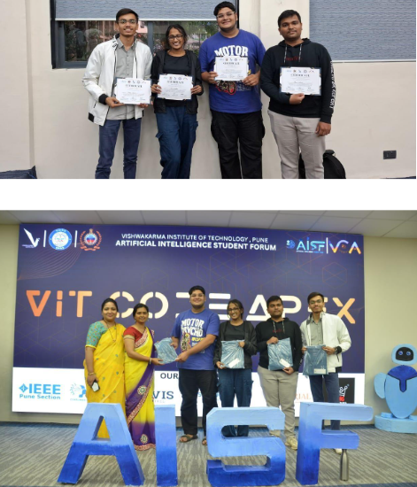
Name of Applicant | Atharva Patwardhan
Name of Competition | AISF 2025
Date of Competition | 24th and 25th Sept
Award/Rank | DRDO Domain 1st Runner up
Prize / Amount Received | Certificates + Goodies
Opportunity
( Placement, internship, Project, Funding etc..)
Team Member Names | Year (FY/SY/TY/FINAL YR) | Department
1) Atharva Patwardhan | TY | CSE (AIML)
2) Atharv Muchandi | TY | CSE (AIML)
3) Vishruti Mohinkar | TY | CSE (AIML)
4) Vedant Nagmoti | TY | CSE (AIML)

Summary
AISF 2025 is a 24-hour national-level hackathon at VIT, Pune, on Sept 24–25, 2025, bringing together innovators from across India to solve real-world challenges in AIML Domain. With ₹40000 in prizes and industry recognition, it’s your chance to build, innovate, and make an impact.

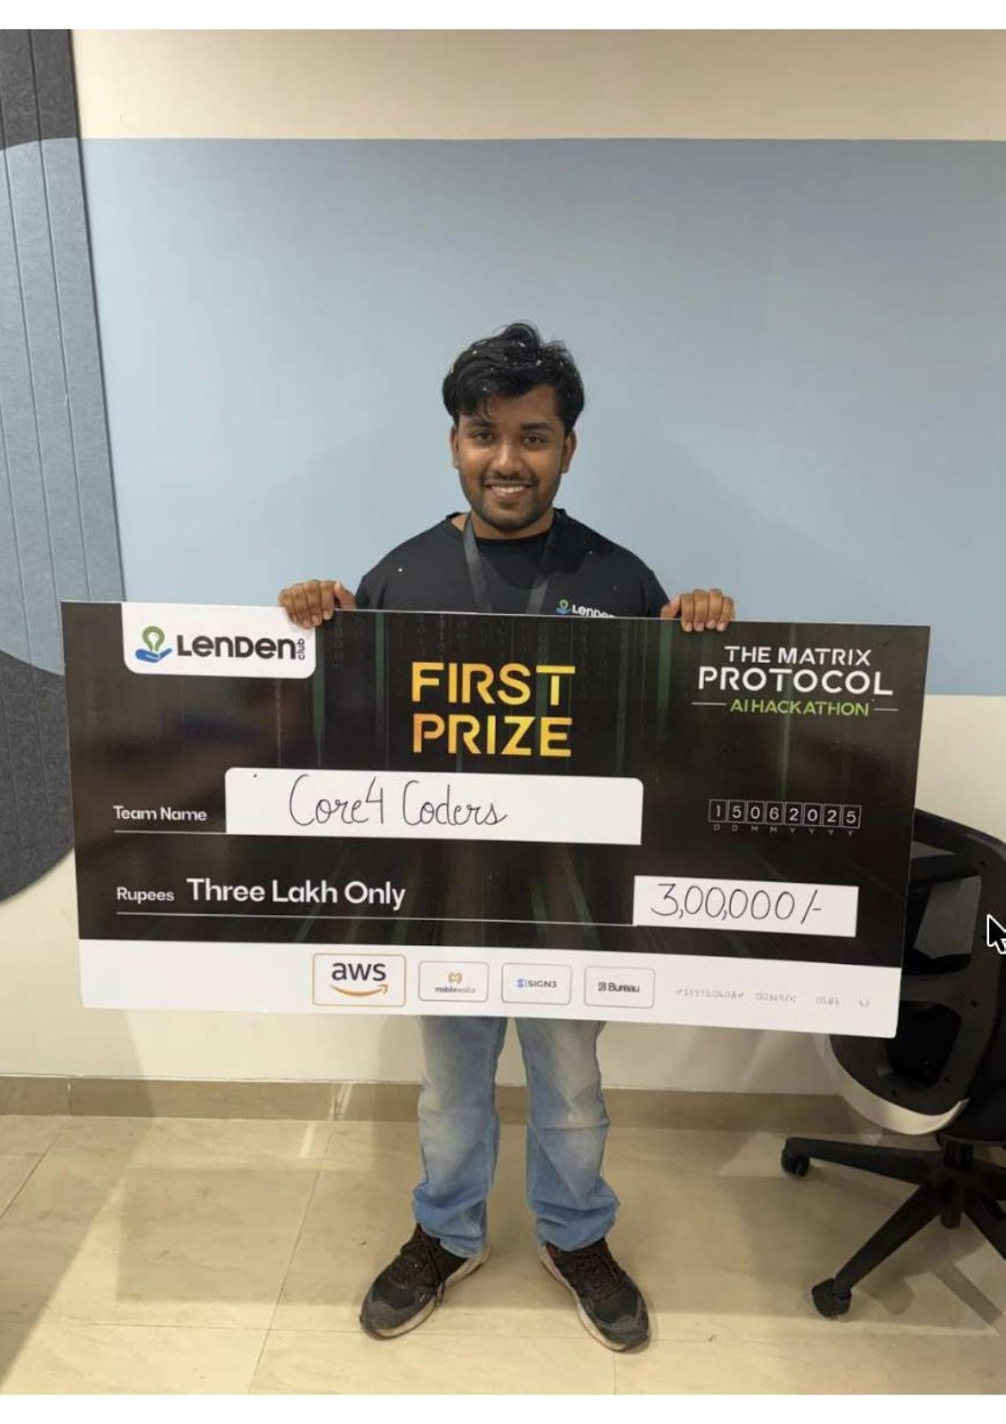
Date of Competition | 15/06/2025
Award/Rank | Winner First Prize
Prize / Amount Received | Rs 3,00,000/-
Opportunity ( Placeemnt, internship, Project, Funding etc..) | Project Competition
Team Member Names | Year
Ayush Srivastava | TY-B
Short Description of the Event | Hackathon (The Matrix Protocol)
Date of Competition | 25/09/2025
Award/Rank | 1st Prize Winner-Ms.Anushka Satav_SY-F_CSE(AI&ML)
Prize / Amount Received | Rs 15,000/-
Opportunity ( Placeemnt, internship, Project, Funding etc..) | Project Code Competition
Team Member Names | Year | Department
Ms.Anushka Satav | SY-F | CSE(AI&ML)
Short Description of the Event | Coding Competition
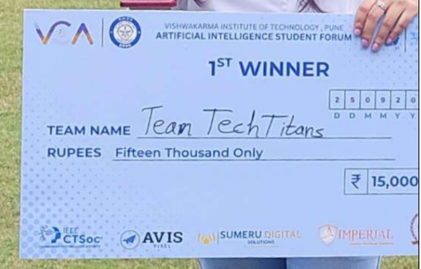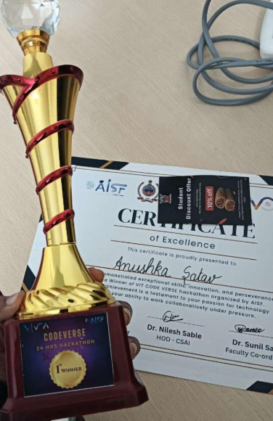

Date of Competition |  | 12/10/2025
Award/Rank |  | 1st Runner Ups at Sociothon
Prize / Amount Received |  | Rs 6,000/-
Opportunity ( Placeemnt, internship, Project, Funding etc..) |  | Project Competition
Team Member Names | Year | Department
Yash Gunjal | TY | CSE(AI&ML)
Ubaid Kundlik | TY | CSE(AI&ML)
Rounak Sondawale | TY | CSE(AI&ML)
Sanskar Raut | TY | CSE(AI&ML)
Short Description of the Event | Innovative Project Competition Organized by Social Welfare and Development Committee,VIT.
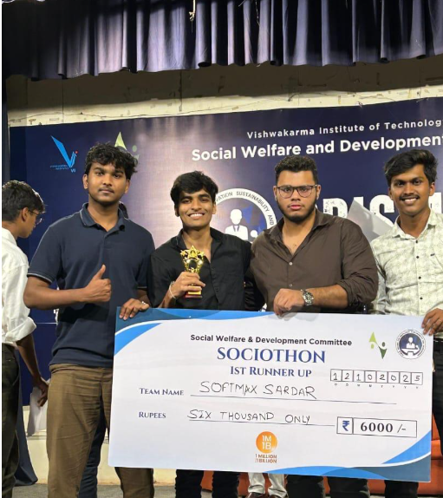
Date of Competition |  | 11/10/2025
Award/Rank |  | 1st Runner-Up position at the London School of Economics’ “LSE Generate” Startup Competition
Prize / Amount Received |  | Rs 90,000/-
Opportunity ( Placeemnt, internship, Project, Funding etc..) |  | Start-ups Competition
Team Member Names | Year | Department
Priyansh Jain | SY-C | CSE(AI&ML)
Sidra Jahangir | SY-C | CSE(AI&ML)
Short Description of the Event | London School of Economics’ “LSE Generate” Startup Competition

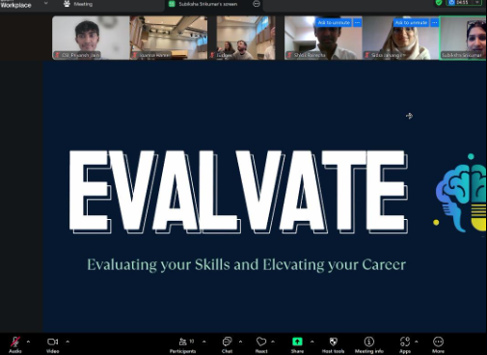
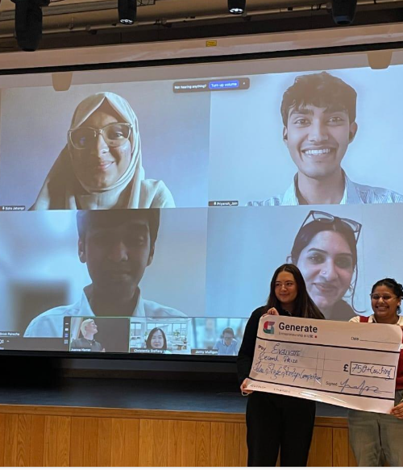
Date of Competition |  | 10/10/2025
Award/Rank |  | Fusion Hackathon* Rank-1 in the Healthcare Domain
Prize / Amount Received |  | Rs 10,000/-
Opportunity ( Placeemnt, internship, Project, Funding etc..) |  | Project Competition
Team Member Names | Year | Department
Atharva Patwardhan | TY | CSE(AI&ML)
Vishruti Mohinkar | TY | CSE(AI&ML)
Atharv Muchandi | TY | CSE(AI&ML)
Vedant Nagmoti | TY | CSE(AI&ML)
Short Description of the Event | Fusion Hackathon by SKNCOE Vadgaon,Pune. Innovative Project Competition
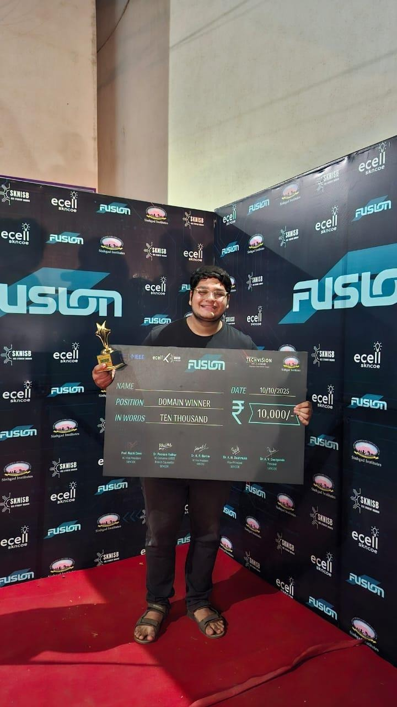
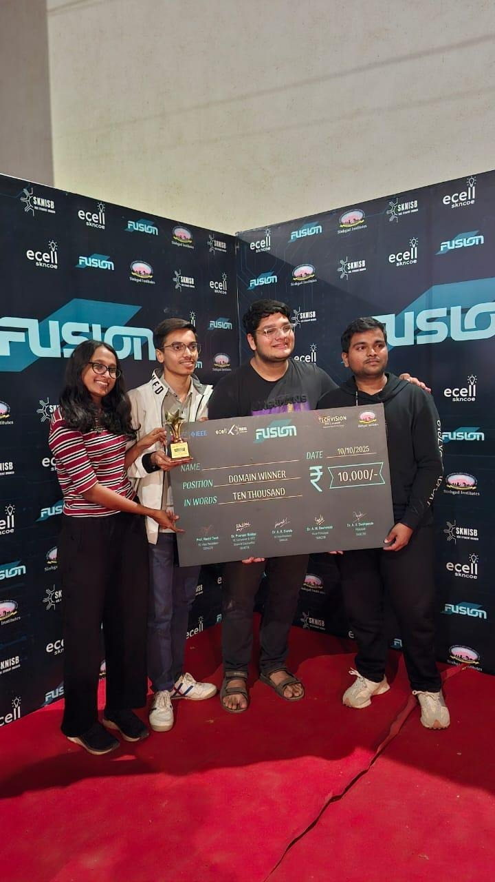
Date of Competition | 13/10/2025
Award/Rank | 1st runner up
Prize / Amount Received | Rs 5,000/- (Rupees five thousands only)
Opportunity ( Placeemnt, internship, Project, Funding etc..) | Project Exhibition
Team Member Names | Year | Department
Snehal Kumbhar | TY | CSE(AI&ML)
Shalvi Shah | TY | CSE(AI&ML)
Varun Sakharkar | TY | CSE(AI&ML)
Parth Amilkanthwar | TY | CSE(AIDS)
Short Description of the Event | Hacktopia Hackathon By PCCOE,Akurdi,Pune. It’s Innovative Project Exhibition.
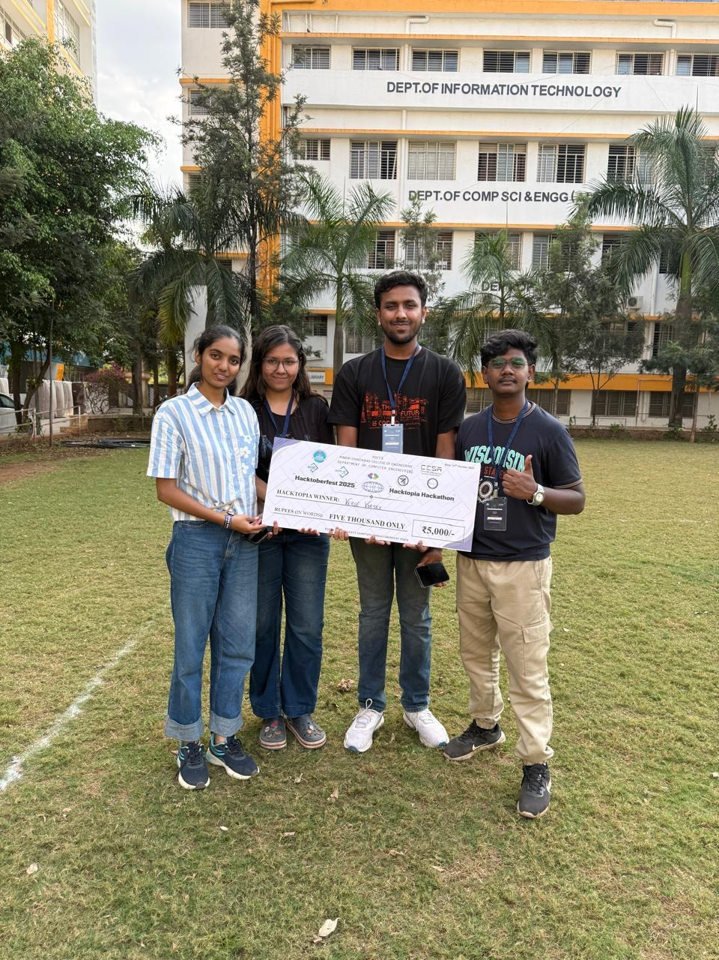
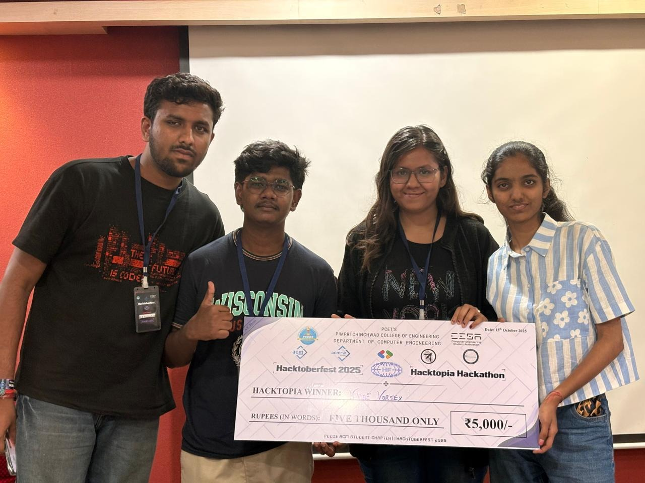
Date of Competition | 13/10/2025
Award/Rank | Project Completion Certificate
Prize / Amount Received | Project Completion Certificate
Opportunity ( Placeemnt, internship, Project, Funding etc..) | Industry Live Project
Short Description of the Event | Dr. Prakash Sharma, Founder, Passion Infotech Pvt Ltd and Pcombinators offered the completion certificates to the students.
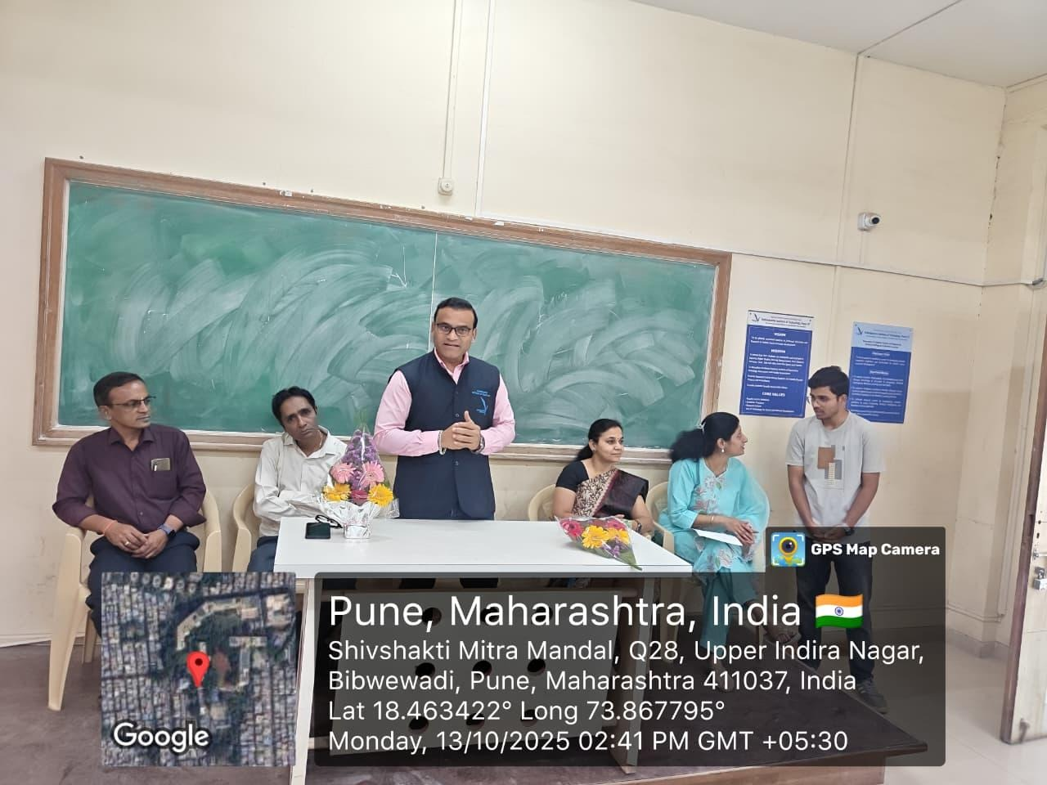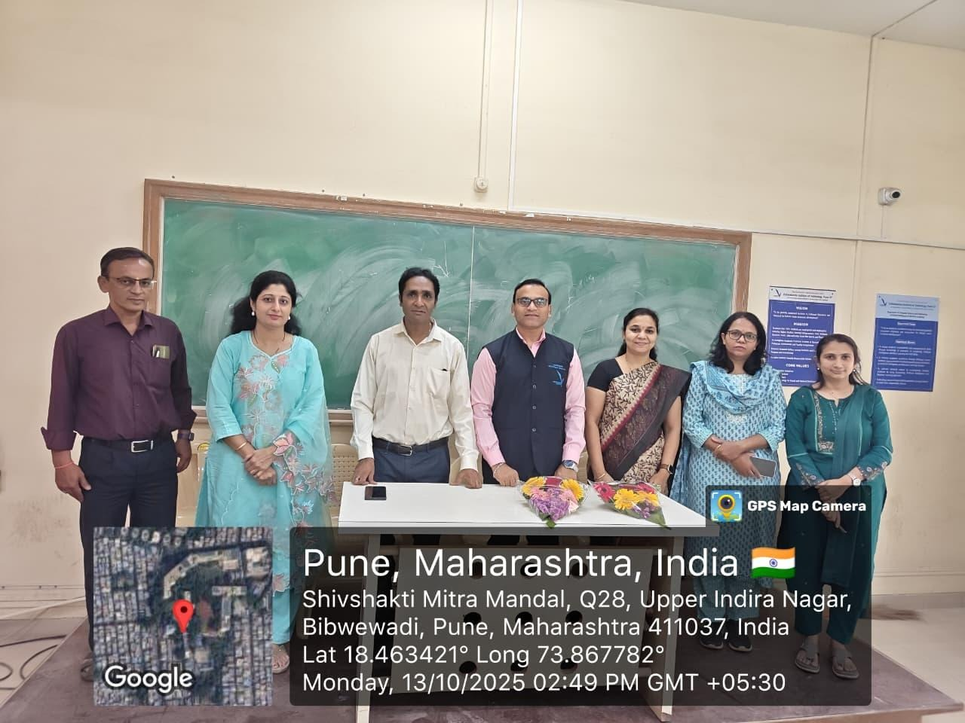
Date of Competition | 11/10/2025
Award/Rank | Team deathwing secured 1st place in QuestCON CTF organised by OWASP PCCOE Pune
Prize / Amount Received | Winner Certificate
Opportunity ( Placeemnt, internship, Project, Funding etc..) | Project
Team Member Names | Year | Department
Abhinandan Bhuse | TY | AIDS
Devraj Lokhande | TY | CSE(AI&ML)
Pranil Gholap | TY | AIDS
Pranav Vibhute | TY | AIDS
Short Description of the Event | QuestCON CTF organised by OWASP PCCOE Pune
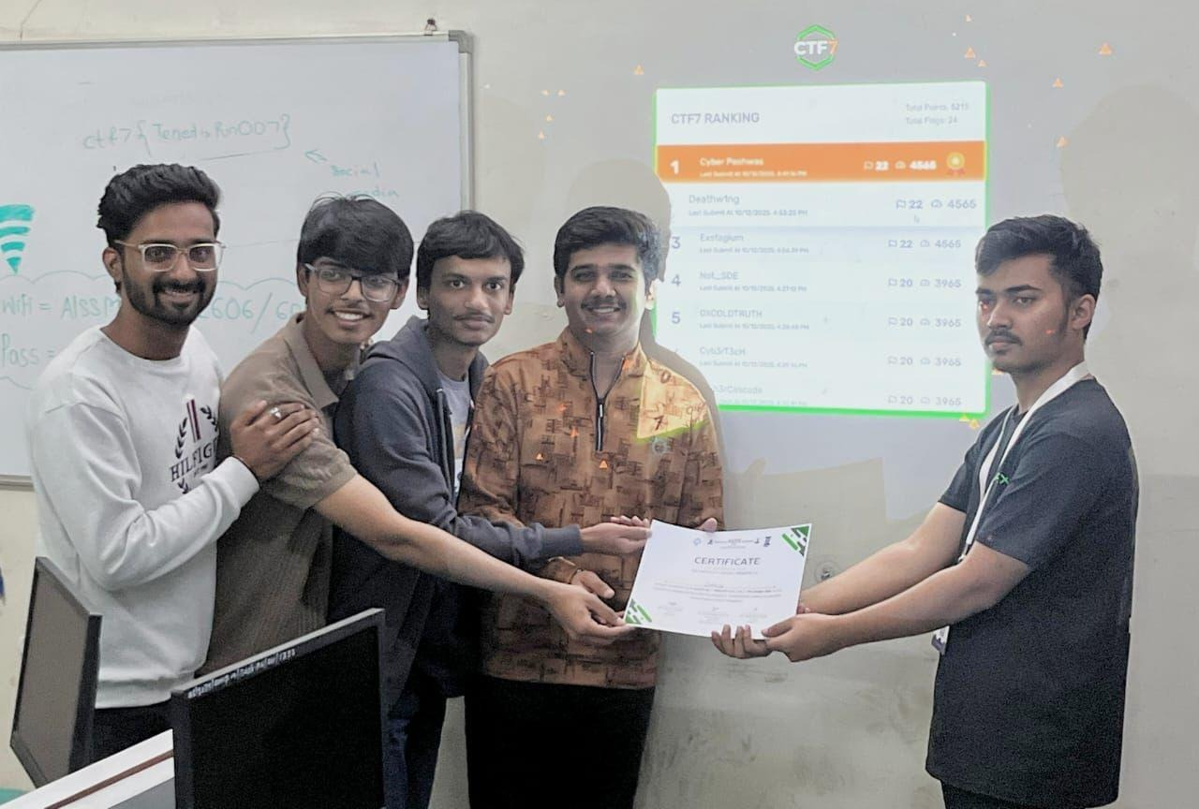

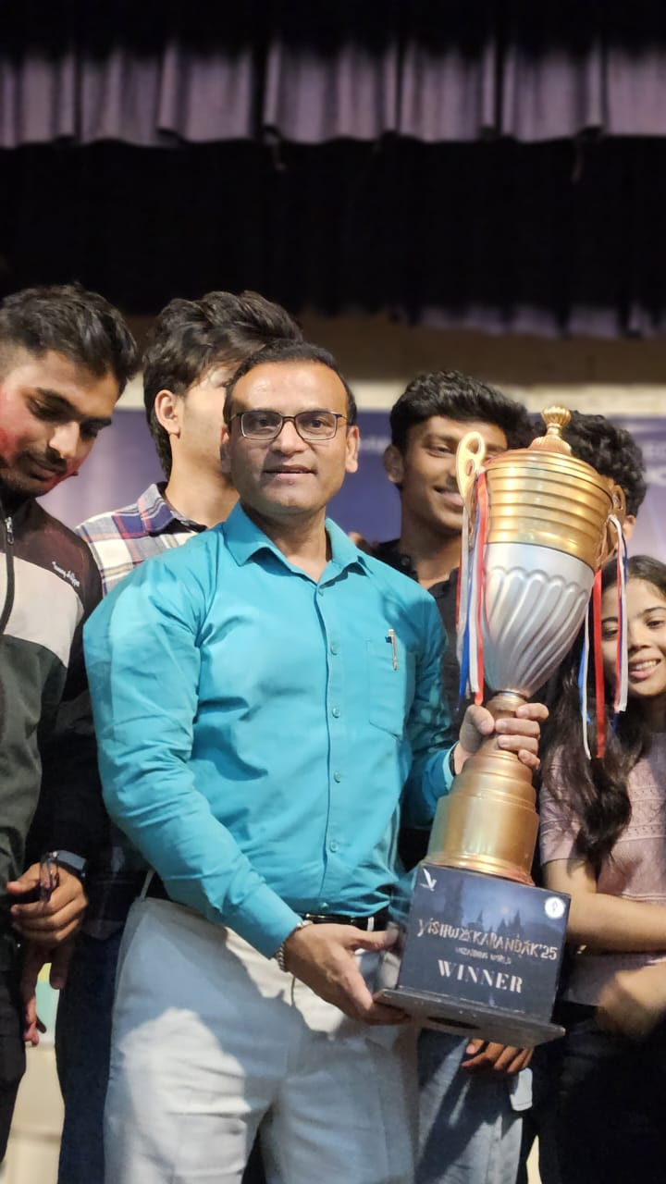
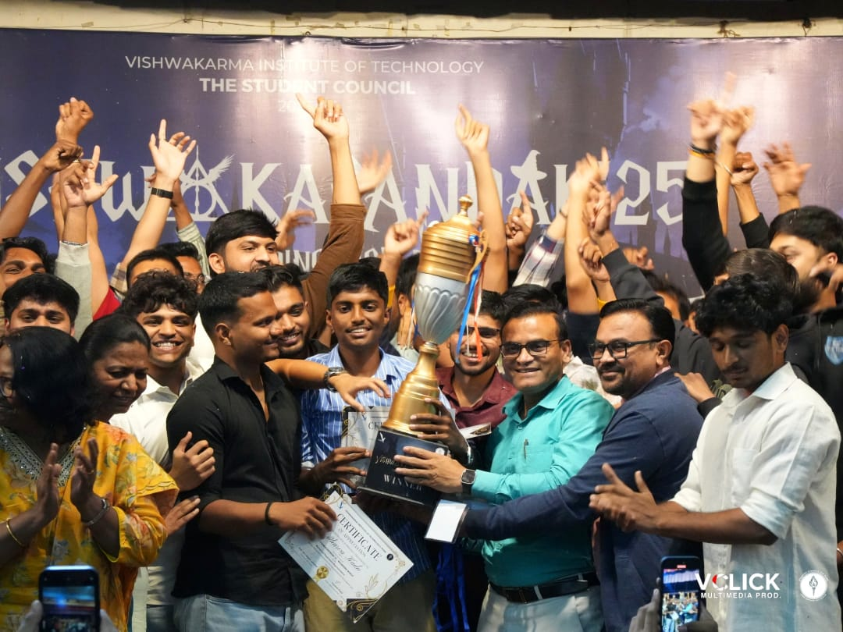
CSE(AI&ML) Won Vishwakarandak 2025 at VIT,Pune

IEEE CIS Chapter
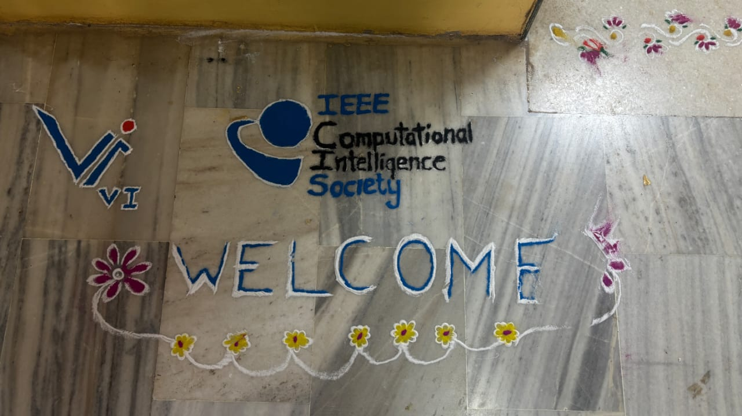
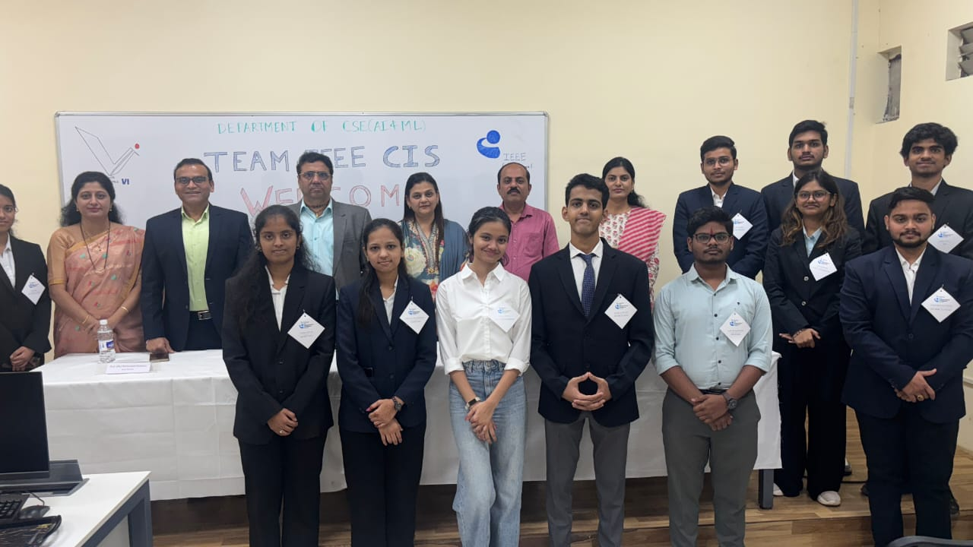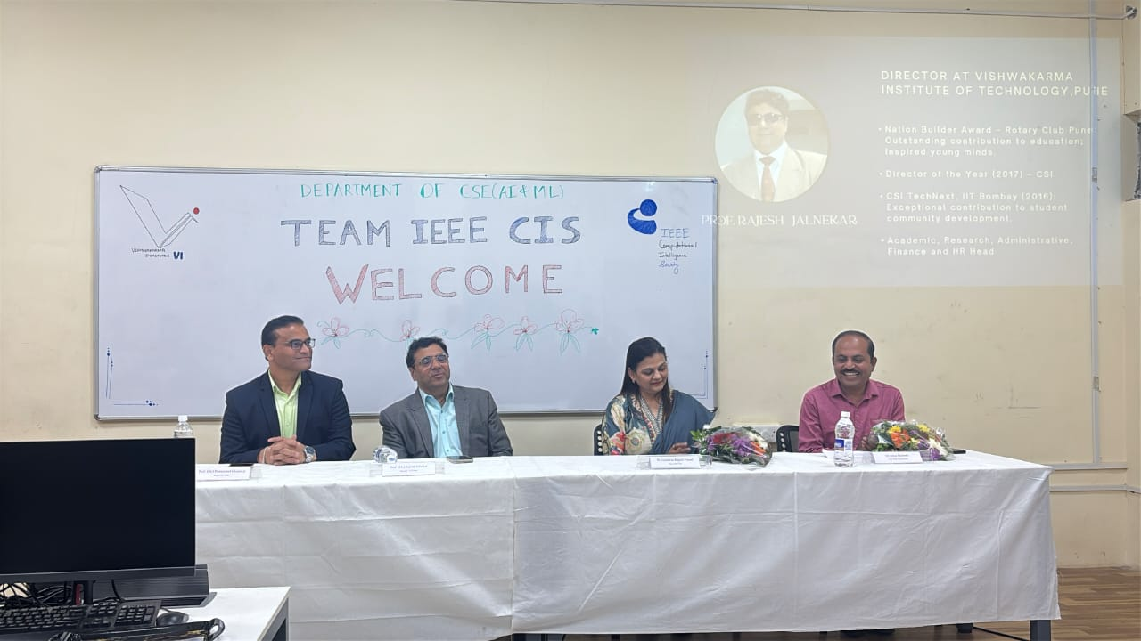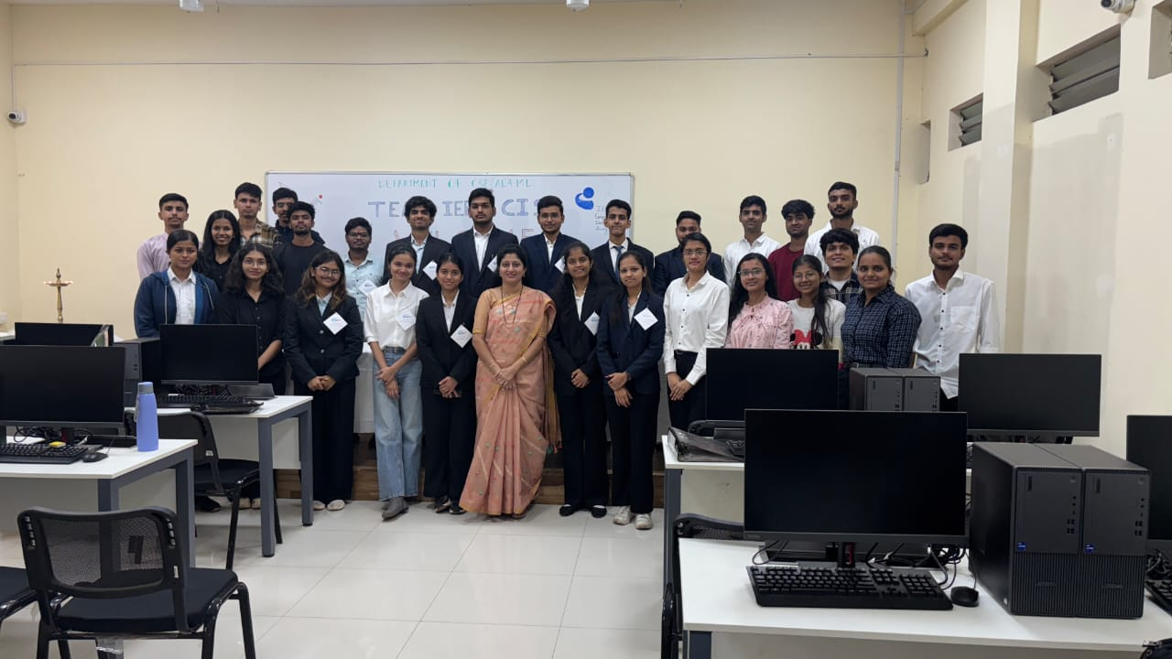
Summary
CSE(AI&ML) Department started IEEE CIS student chapter at VIT,Pune on 4th December 2025.HoD Dr.Premanand Ghadekar Dr.Jyoti Kanjalkar-Secretary IEEE Pune Region along with all faculty members of CSE(AI&ML) department,Director- Dr Rajesh Jalnekar ,Dr.Amar Buchade,Dr.Jayashree Prasad- chief guest of this event were present for this event.

CONFERENCE-ICSCAI 2025

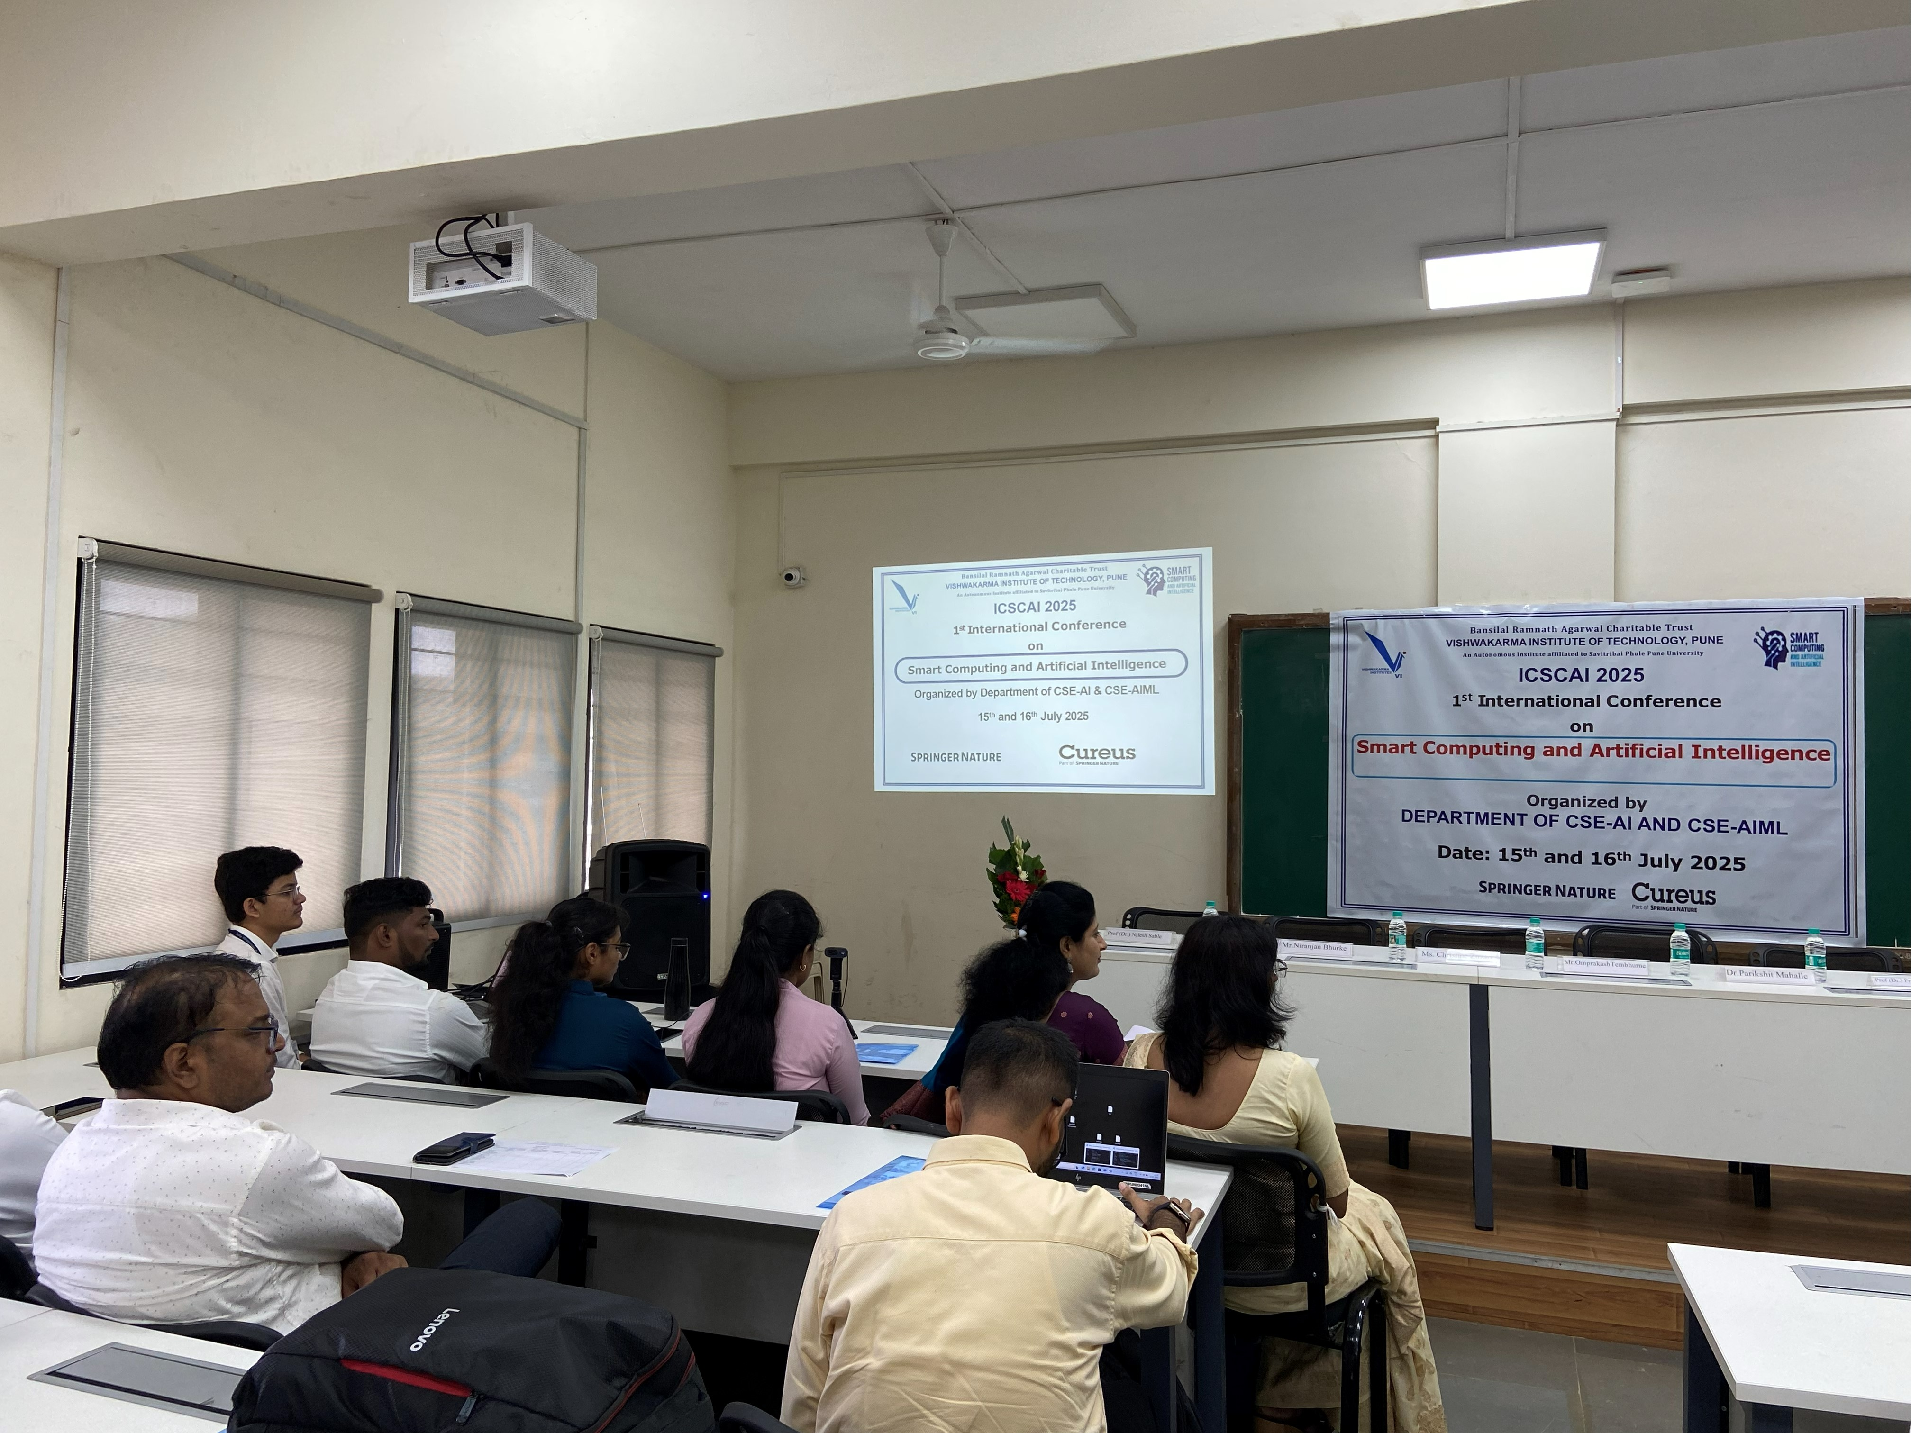
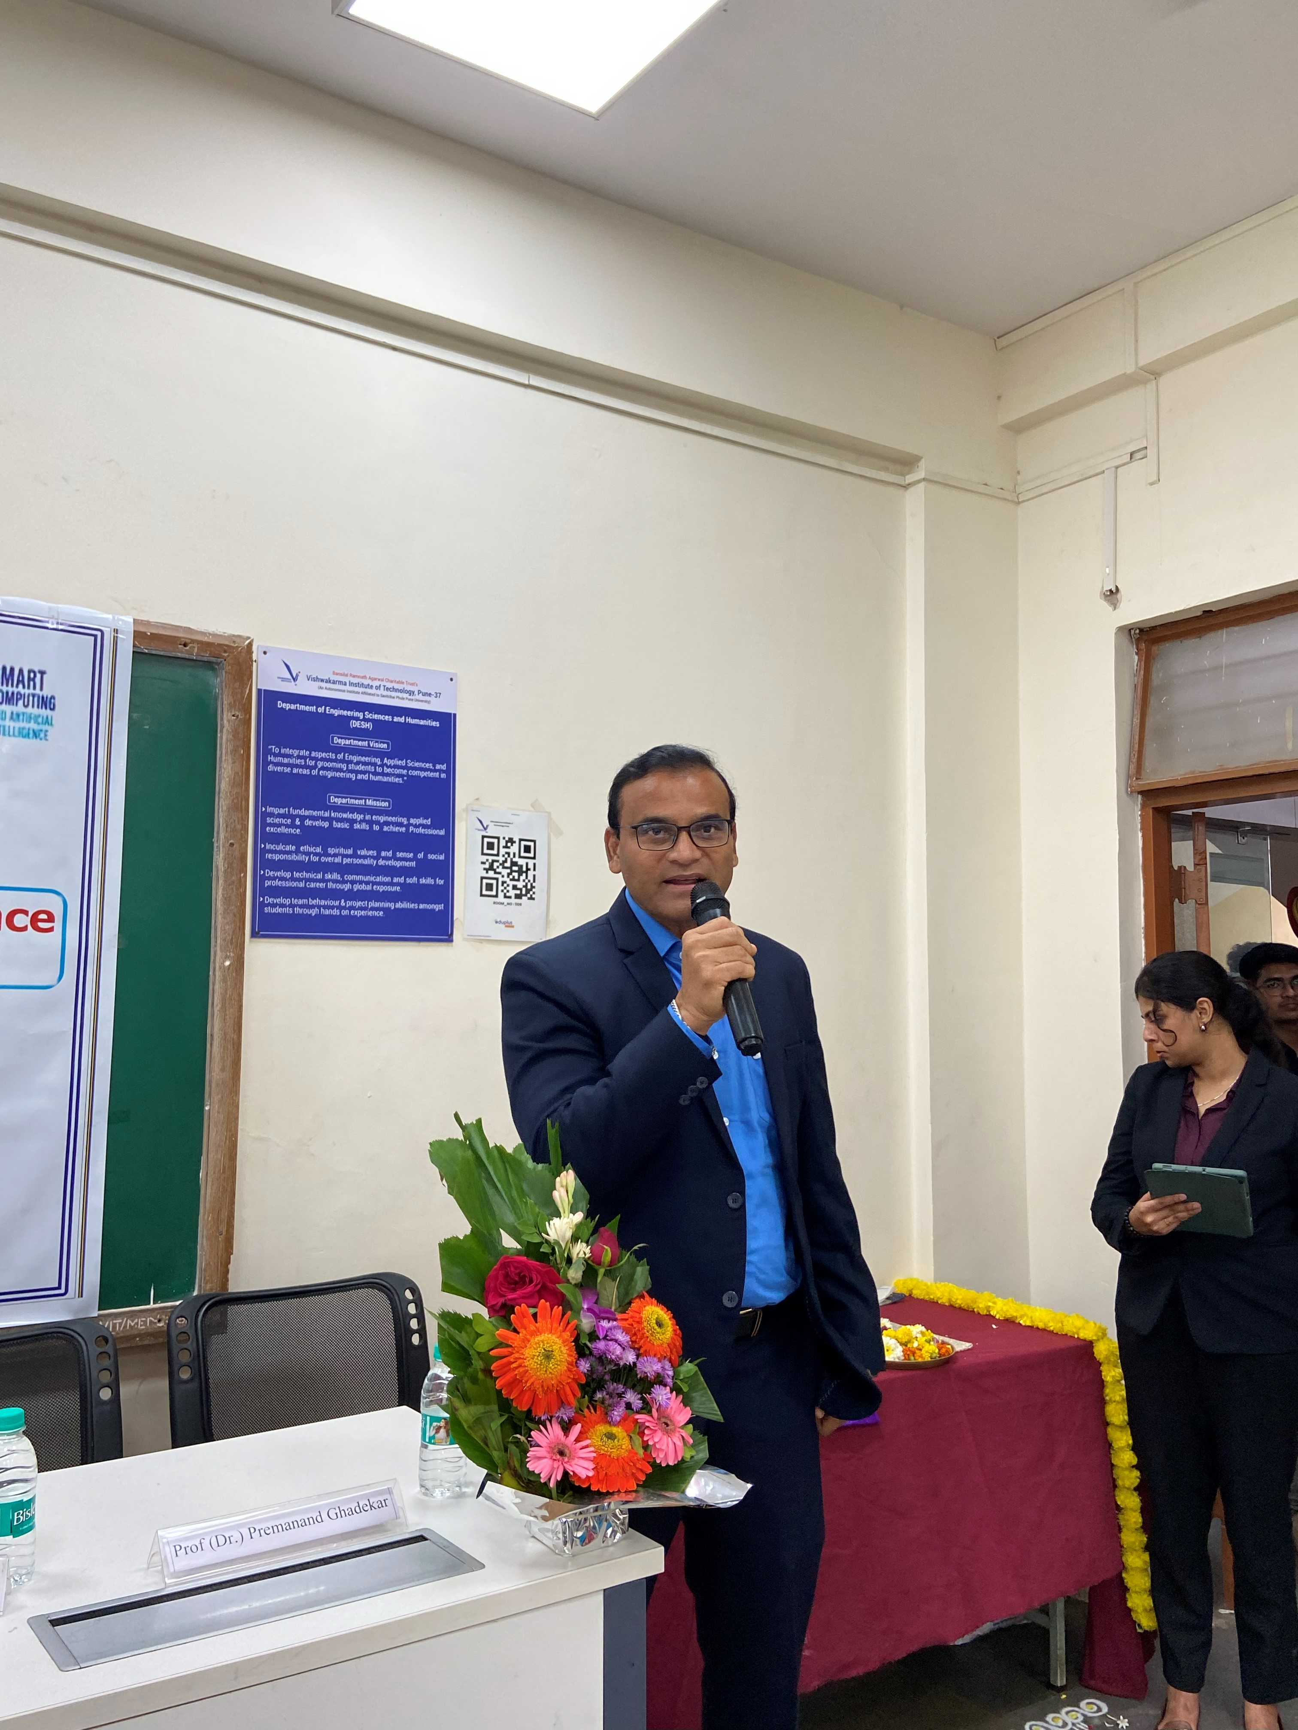
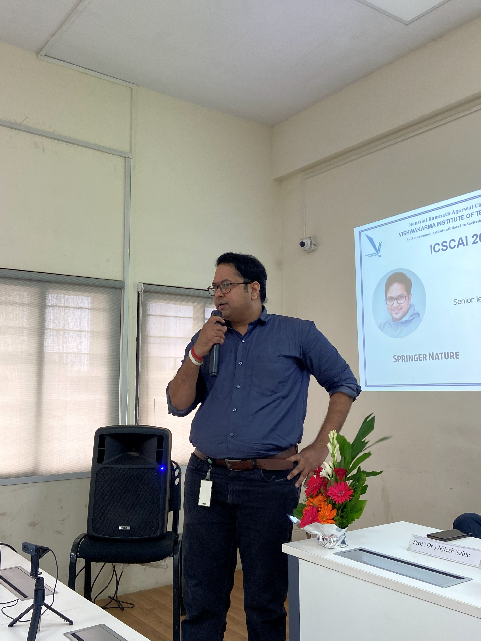

EVENT-CONFERENCE-ICSCAI JULY 2025
VENUE-CSE(AI&ML) , VIT,PUNE.
VIT Pune Successfully Hosts ICSCAI 2025! 
We are proud to share that Vishwakarma Institute of Technology, Pune successfully organized the International Conference on Smart Computing and Artificial Intelligence (ICSCAI 2025) on 15 July and 16 July, 2025.
The event was jointly organized by the Department of Computer Engineering (Artificial Intelligence) and the Department of Artificial Intelligence & Machine Learning (AIML).
The conference brought together a vibrant community of researchers, students, academicians, and industry professionals to explore the latest trends in Artificial Intelligence, Machine Learning, and Smart Computing through six specialized tracks.
We were honored to welcome Ms. Christine Zuzart (HCL) – Chief Guest, Mr. Omprakash Tembhurne (Springer Nature) – Guest of Honor, Mr. Niranjan Bhurke (Wolters Kluwer) – Special-Guest.

Faculty Development Program

Title:“Agentic AI for a Smarter, Adaptive, and Responsible Future”

Date & Time: 06/10/2025 to 10/10/2025 , Time: 6.00 PM to 9.00 pm

Co-ordinator for the FDP: Dr.Premanand.P.Ghadekar
Dr.Varsha R.Dange
Prof.Kalyani Ghuge

Organizing Team: Prof.Amruta Bhawarti and Prof.Ashlesha Sawant.

Few Glimpses of Inaugural Function and Session Conducted by Prasad Kulkarni

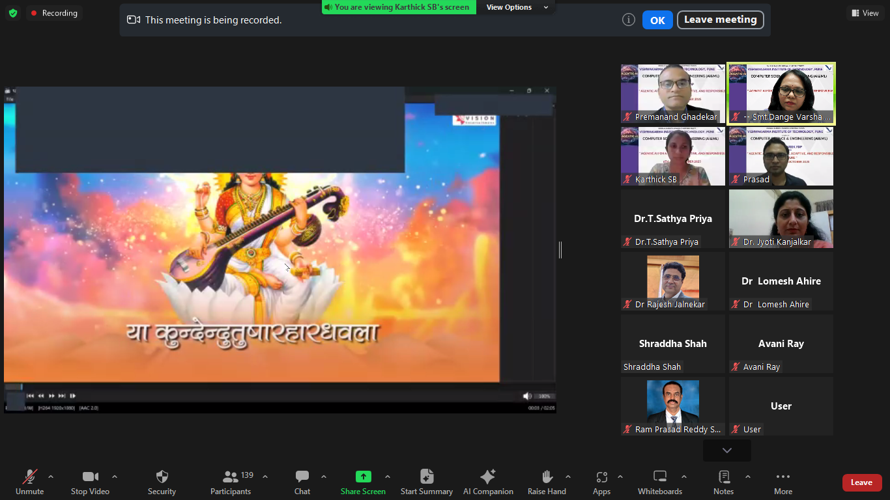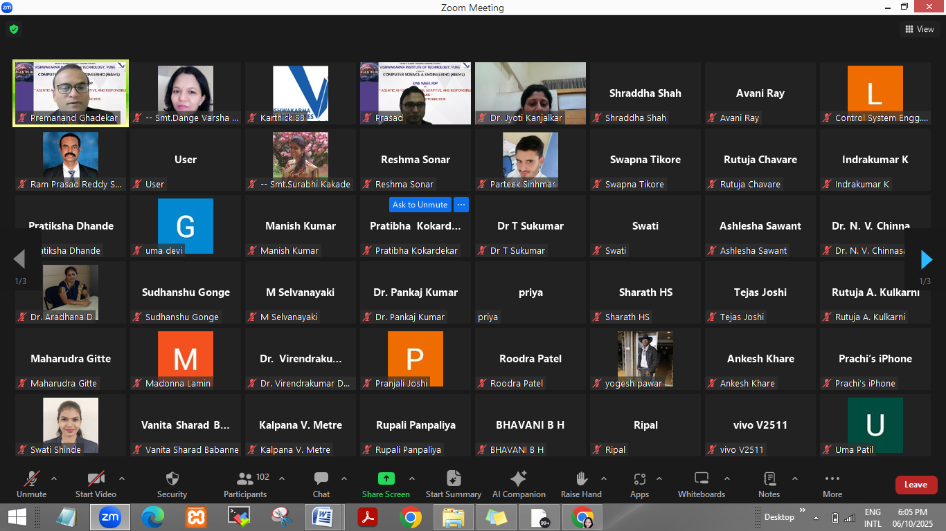
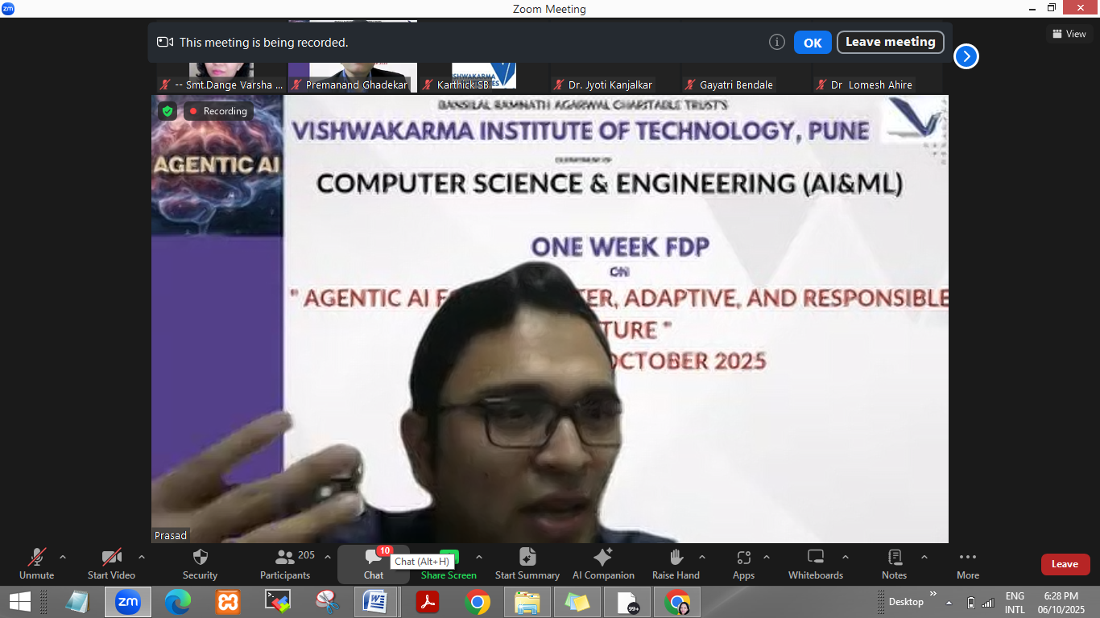

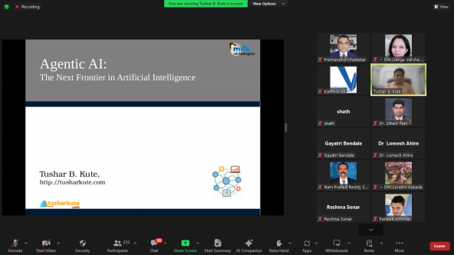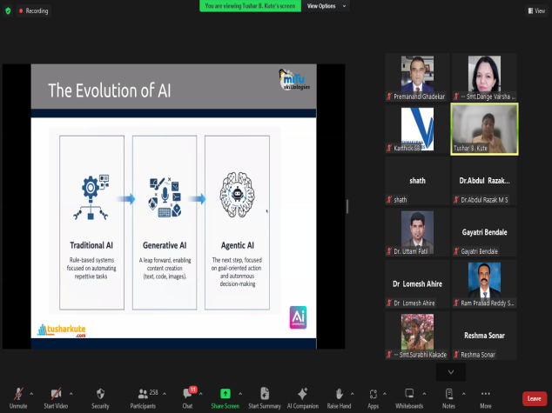
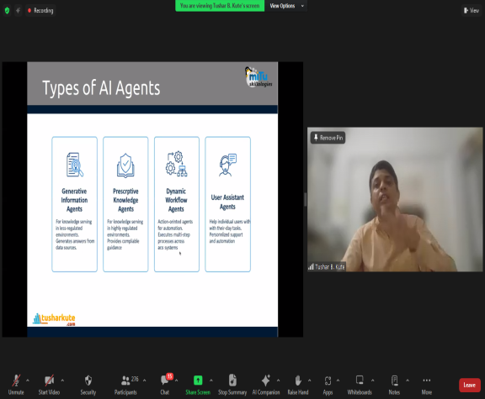

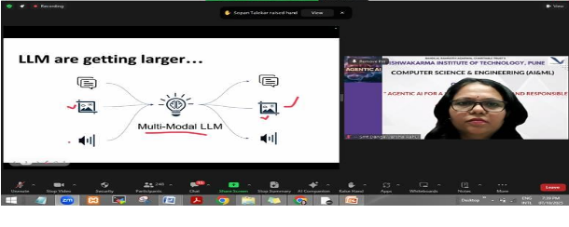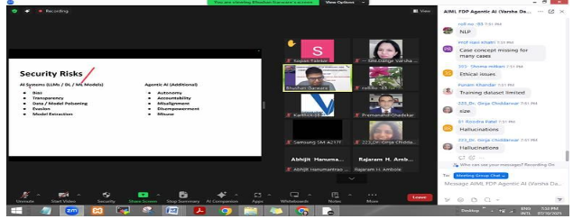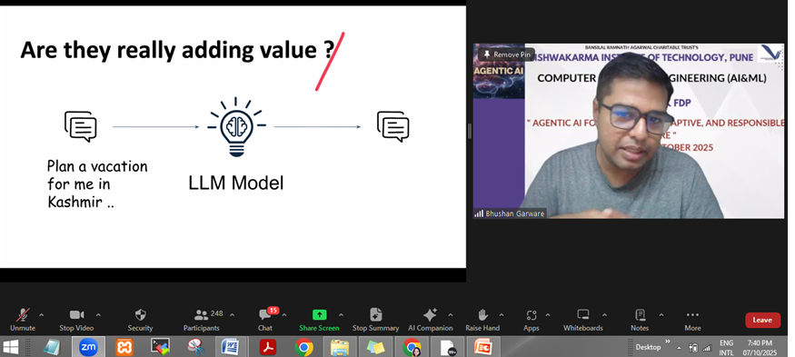
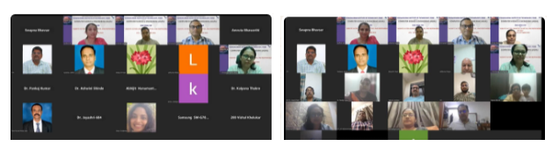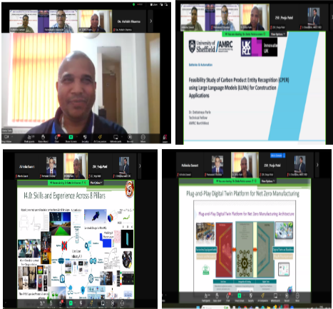

Outcome of FDP

Participants are able to
● Understand the principles of Agentic AI and its core characteristics such as autonomy, adaptability, and proactiveness, and relate them to real-world intelligent systems. (PO1, PO2,PO3)

● Analyze and implement secure and responsible AI practices, addressing challenges like data poisoning, prompt injection, and model robustness in agentic systems. (PO6, PO11)

● Apply Large Language Models (LLMs) and frameworks such as RAG and Model Context Protocol (MCP) to develop intelligent, context-aware, and explainable AI agents. (PO5, PSO1)

● Integrate AI-driven sustainability solutions in domains like construction, business, and healthcare, using data-driven decision-making for social and environmental impact. (PO9, PSO1)

● Formulate ethical AI governance strategies ensuring fairness, accountability, and compliance with emerging AI regulations. (PO6, PO11)

● Utilize agentic frameworks for scalable AI applications and cross-disciplinary innovations. (PO12, PO5)

● Engage in interdisciplinary research combining AI with civil engineering, environmental science, and management to promote sustainable technological growth. (PO9, PSO2)

Title: “One Week Faculty Industry Training Program on Agentic AI”

Date & Time: 01/12/2025 to 05/12/2025 , Time: 10.00 AM to 4.00 pm

Co-ordinator for the FDP: Dr.Premanand.P.Ghadekar
Dr.Amruta Amune

Few Glimpses of Inaugural Function and Session Conducted by Deepneel Majumdar
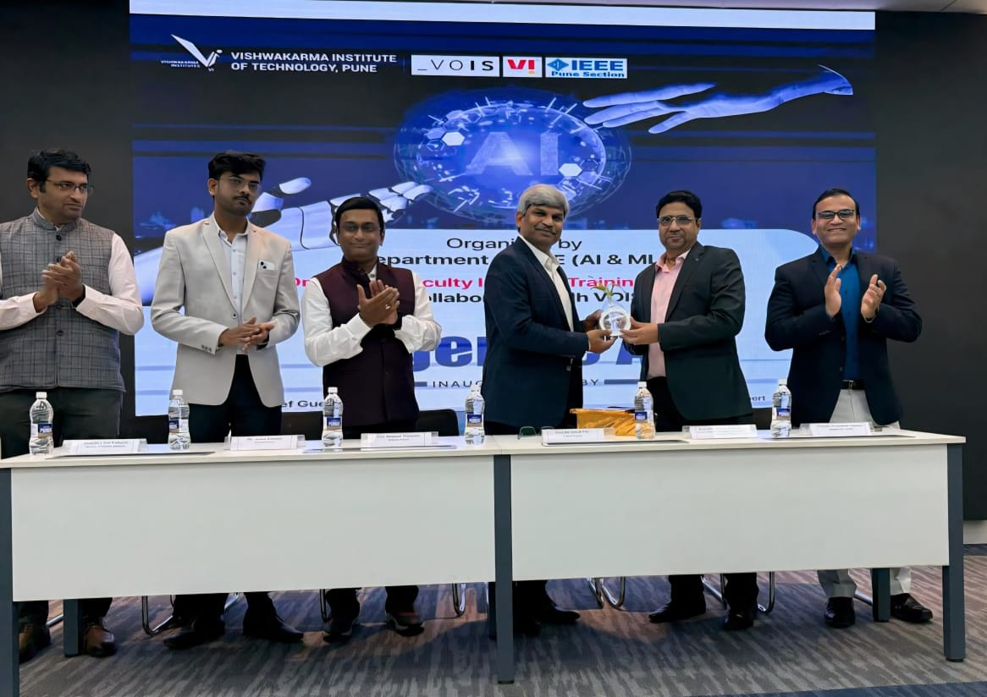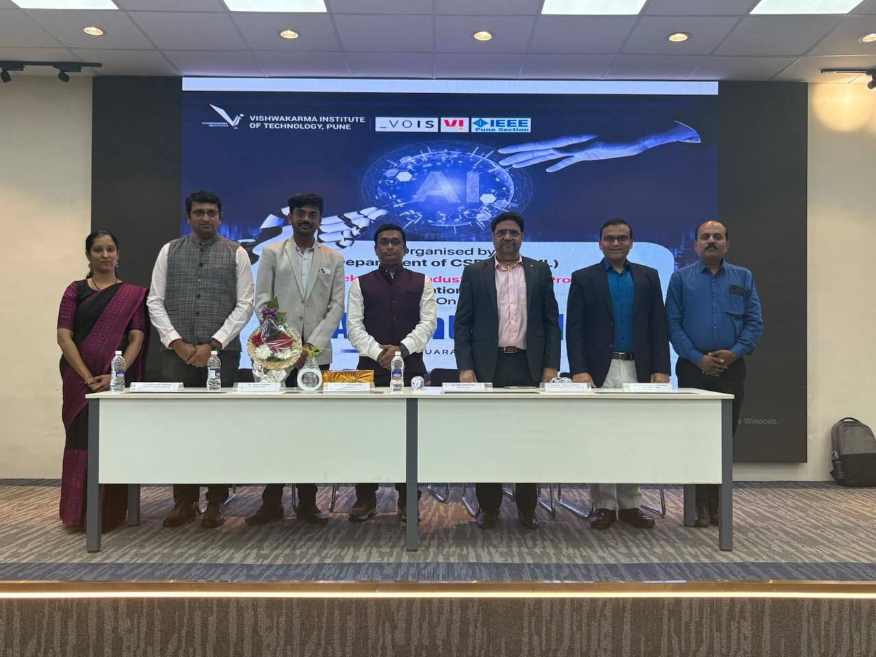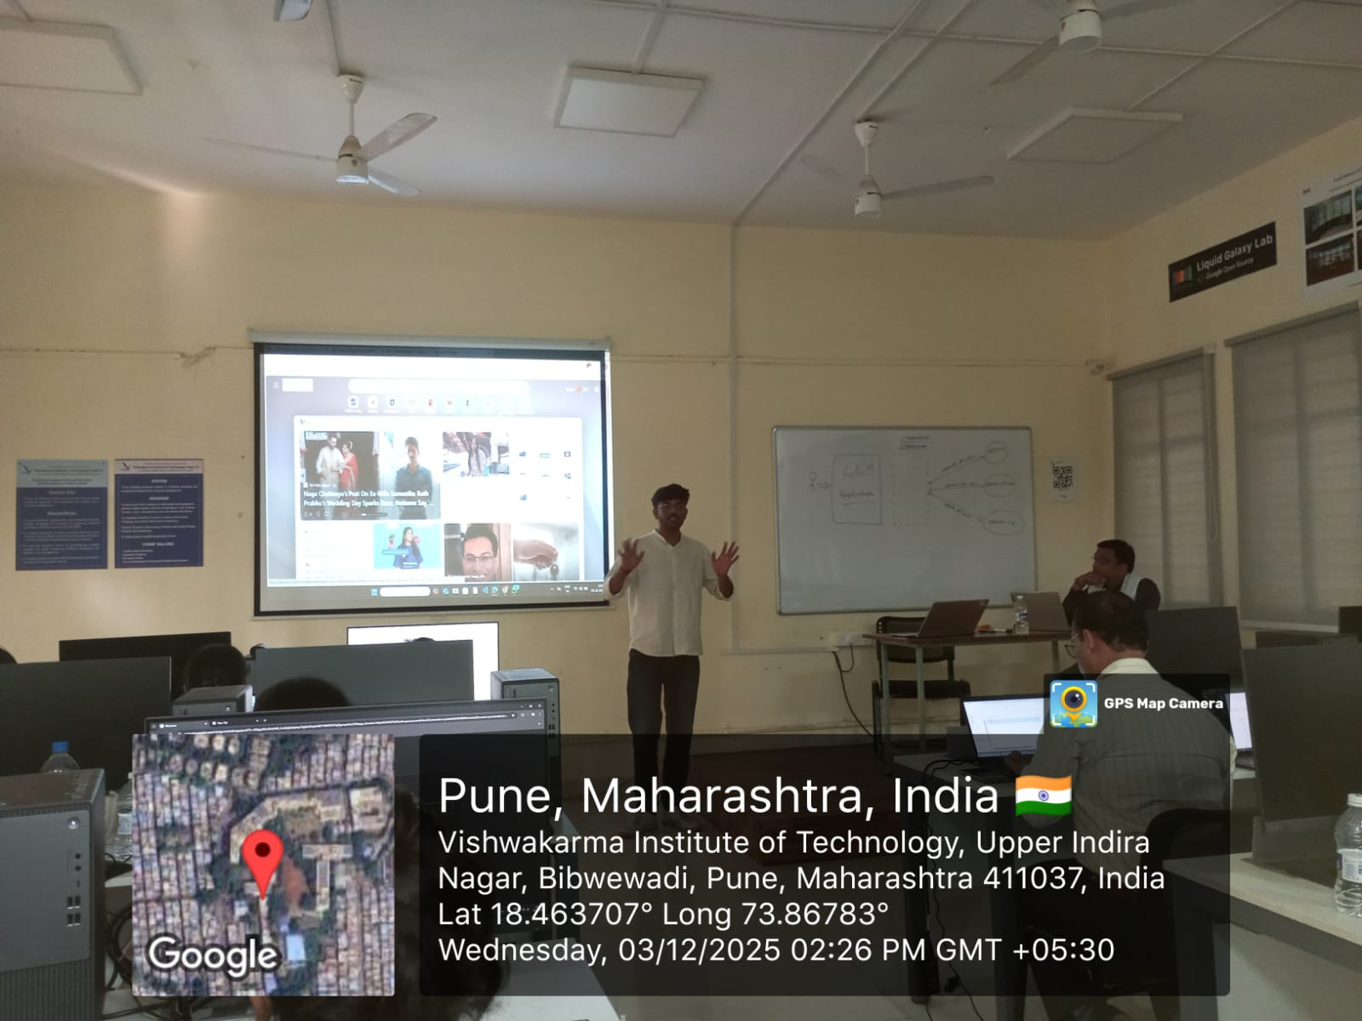
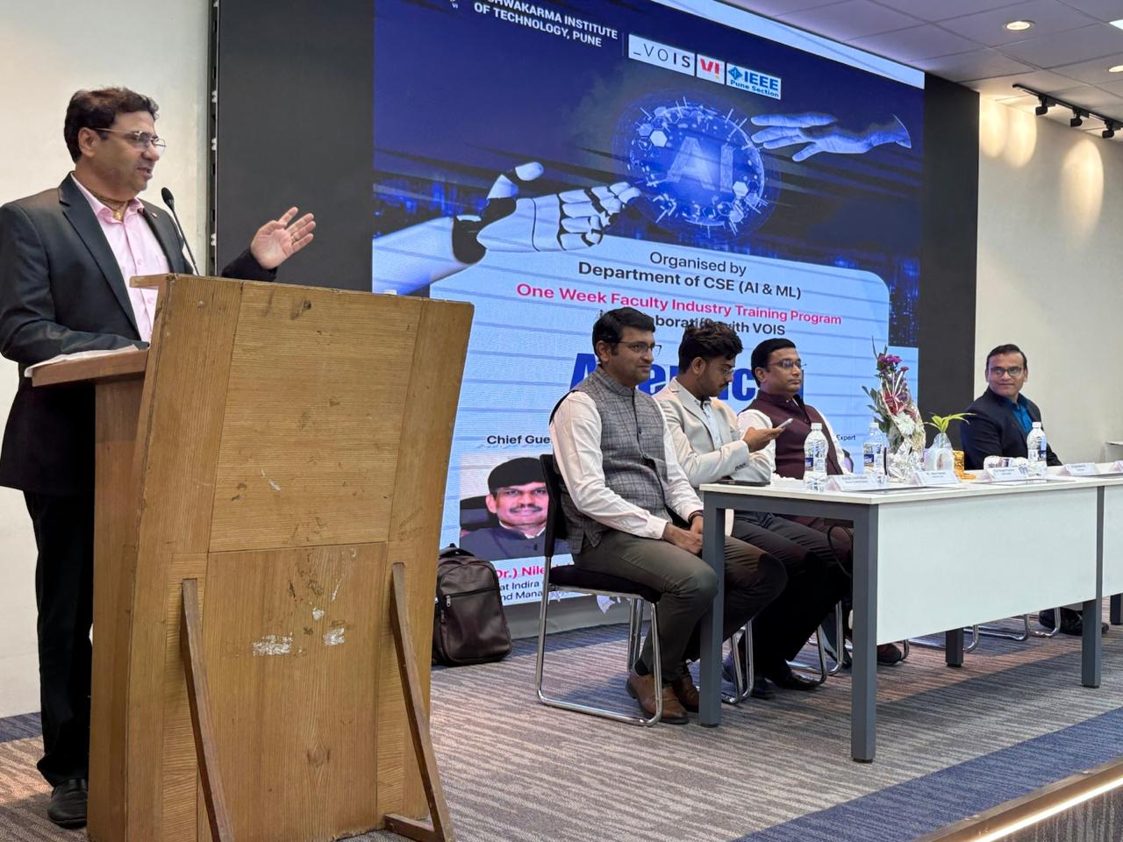

Outcome of FDP

The Department of CSE (AI & ML), VIT Pune, under the guidance of the Hon. Director, successfully organized a one-week Industry Training Program (FDP) on “Agentic AI” in collaboration with Vodafone Intelligent Solutions (VOIS). The program featured expert-led sessions by Mr. Deepneel Majumdar and Mr. Aditya Dambale from VOIS, which were highly interactive, hands-on, and industry-focused.
The training covered advanced Agentic AI architectures, real-world use cases, practical implementations, and industry-ready tools and workflows. Through demonstrations and guided exercises, faculty members gained both strong theoretical insights and practical exposure, empowering them to incorporate emerging AI trends into teaching and research. The FDP significantly enhanced faculty competence in cutting-edge AI technologies and further strengthened industry–academia collaboration. Special acknowledgment is extended to Dr. Amar Buchade and Dr. Atul Kulkarni for their support and contributions.

MOU’S WITH INDUSTRIES

MOU with Zillionlink Pvt. Ltd.
Under the guidance of the Hon. Director, CSE(AI&ML) department has signed a Memorandum of Understanding (MoU) with Zillionlink Pvt. Ltd. This collaboration aims to create valuable opportunities for students and the institution through expert sessions, sponsored projects, hackathons, internships, placements, and lab development. The partnership is expected to foster mutual growth and success and was facilitated by Dr. Jyoti Kanjalkar.

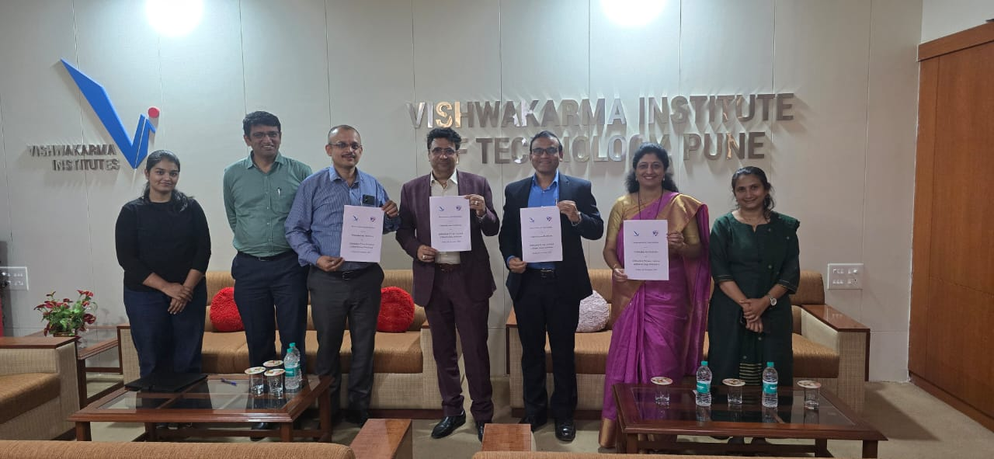
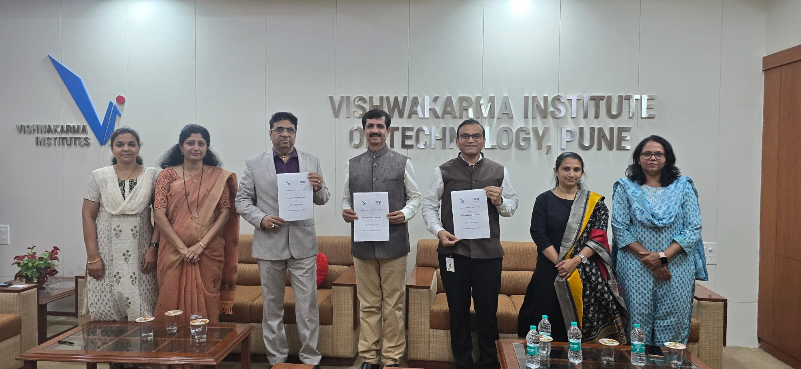

MOU With ANP Enterprises

Under the guidance of the Hon. Director, CSE(AI&ML) department has signed a Memorandum of Understanding (MoU) with ANP Enterprises. This collaboration will support faculty and students through expert sessions, industry-sponsored projects, lab development, hackathons, internships, and placement opportunities. The MoU was facilitated by Dr. Jyoti Kanjalkar.

.
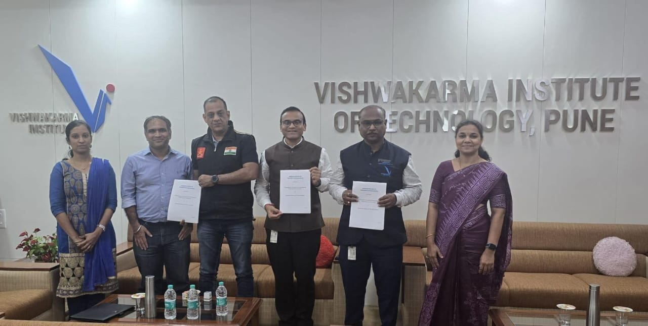

MOU With ZENWORKS SOLUTIONS (MYELIN) PVT. LTD

Under the guidance of the Hon. Director, CSE(AI&ML) department has signed a Memorandum of Understanding (MoU) with Zenworks Solutions (Myelin) Pvt. Ltd. As part of this collaboration, students are already engaged in company-sponsored projects. The partnership will support faculty and students through training in emerging technologies, startup guidance, sponsored projects, lab development, hackathons, internships, and placement opportunities.

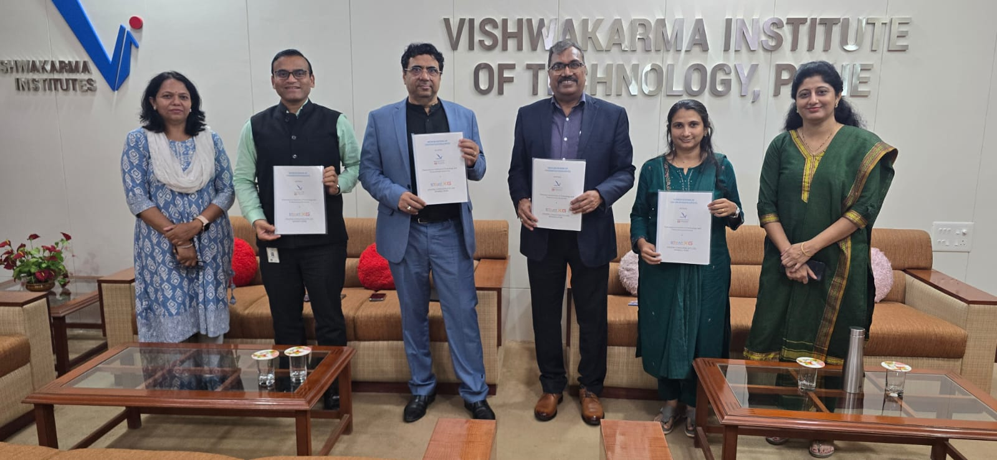

MOU WITH STRATXG CONSULTING PVT. LTD.

Under the guidance of the Hon. Director, CSE(AI&ML) department has signed a Memorandum of Understanding (MoU) with STRATXG Consulting Pvt. Ltd. This collaboration will support faculty and students through training in emerging areas, sponsored projects, lab development, hackathons, internships, and placement opportunities. The collaboration was facilitated by Ms. Kalyani Ghuge.

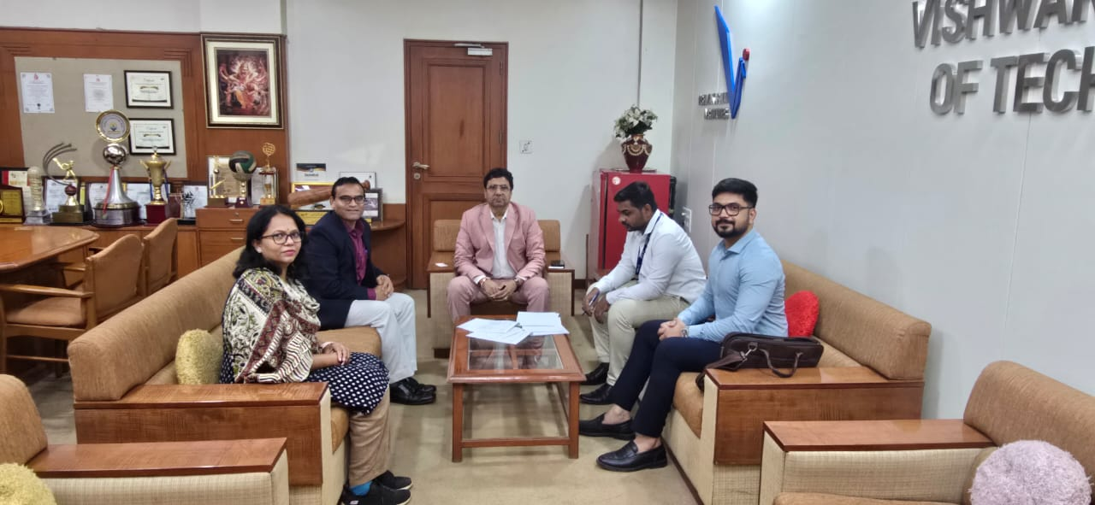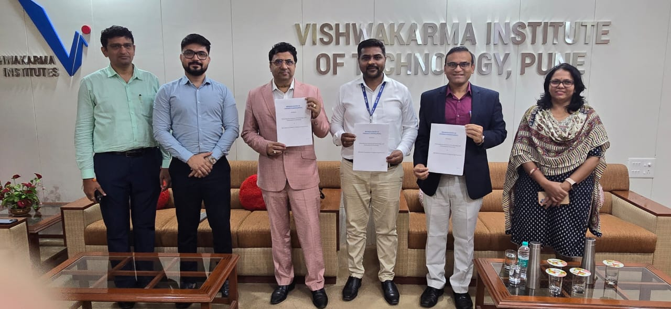

MOU With Maharashtra Industrial Technical Consultancy Organisation Limited (MITCON).

Under the guidance of the Hon. Director, CSE(AI&ML) department has signed a Memorandum of Understanding (MoU) with Maharashtra Industrial Technical Consultancy Organisation Limited (MITCON). This collaboration will benefit faculty and students through training in emerging areas, sponsored projects, lab development, hackathons, internships, and placement opportunities.

