Structure & Syllabus of Mechanical Engineering of pattern A16 (2016-17 FY to 2019-20)

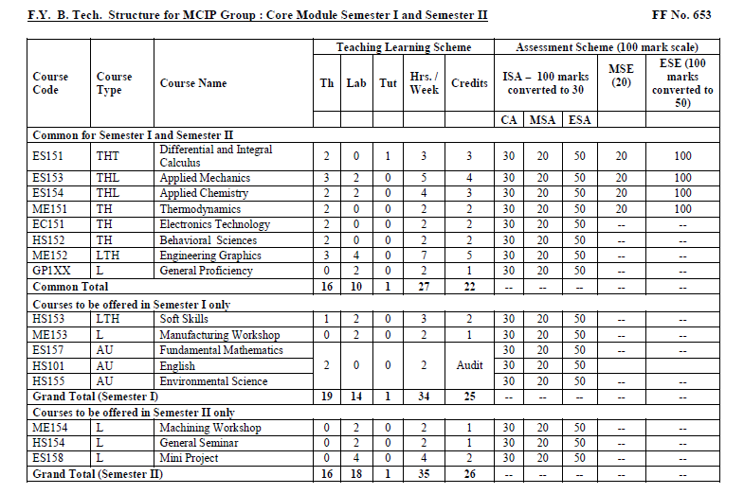

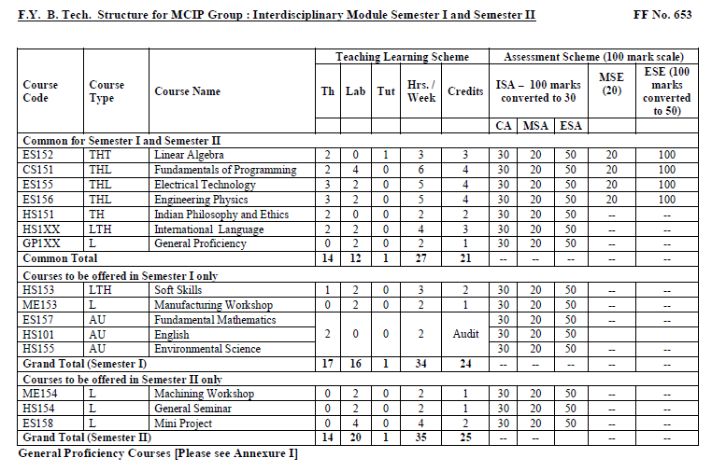

Structure for S.Y. Mechanical Engineering
Academic Year – 2017-18
Module-III
Course | Course Code New | Course Name | Course | Contact Hours / Week |  |  | Assessment Scheme |  |  |  |  |  | Total Marks | Credits
 |  |  | Type |  |  |  | ISA |  |  | ISA | MSE | ESE
 |  |  |  |  |  |  | Breakup
 |  |  |  | Th. | Project based Lab | Regular Lab | CA | MSA | ESA
S₁ | ME201TLP | Kinematics and Mechanisms | TLP | 3 | - | 2 | 30 | 20 | 50 | 30 | 35 | 35 | 100 | 4
S₂ | ME202THL | Applied Thermodynamics | THL | 3 | - | 2 | 30 | 20 | 50 | 30 | 35 | 35 | 100 | 4
S₃ | ME203THL | Material Science | THL | 3 | - | 2 | 30 | 20 | 50 | 30 | 35 | 35 | 100 | 4
S₄ | ME204THP | Machine Drawing* | THP | 3 | 2 | - | 30 | 20 | 50 | 30 | 35 | 35 | 100 | 4
S₅ | ME205TH | Manufacturing Processes | TH | 3 | - | - | 30 | 20 | 50 | 30 | 35 | 35 | 100 | 3
S₆ | HS202OPE | Costing and Cost Control | OPE | 2 | - | - | - | - | - | 10 | 20 | 70 | 100 | 2
S₇ | ME206LAB | Workshop Practice | LAB | - | - | 2 | 30 | 20 | 50 | 100 | - | - | 100 | 2
TOTAL |  |  |  | 17 | 2 | 8 |  |  |  |  |  |  |  | 23
* S₄ –Machine Drawing - Irrespective of module in FIRST semester
* S₆ – Costing and Cost Control - Irrespective of module in FIRST semester

Structure for S.Y. Mechanical Engineering Academic Year – 2017-18 Module-IV
Course | Course Code | Course Name | Course | Contact Hours / Week |  |  | Assessment Scheme |  |  |  |  |  | Total Marks | Credits
 |  |  | Type |  |  |  | ISA |  |  | ISA | MSE | ESE
 |  |  |  |  |  |  | Breakup
 |  |  |  | Th. | Project based Lab | Regular Lab | CA | MSA | ESA
S₁ | ME207THP | Strength of Machine Elements | THP | 3 | 2 | - | 30 | 20 | 50 | 30 | 35 | 35 | 100 | 4
S₂ | ME208THL | Fluid Mechanics | THL | 3 | - | 2 | 30 | 20 | 50 | 30 | 35 | 35 | 100 | 4
S₃ | ME209THP | Modeling & Simulation of Mechanical Systems* | THP | 3 | 2 |  | 30 | 20 | 50 | 30 | 35 | 35 | 100 | 4
S₄ | ME210THL | Electrical & Electronics Engineering | THL | 3 | - | 2 | 30 | 20 | 50 | 30 | 35 | 35 | 100 | 4
S₅ | ME211TH | Differential Equations And Vector Analysis | TH | 3 | - | - | 30 | 20 | 50 | 30 | 35 | 35 | 100 | 3
S₆ |  | Engineering and Managerial Economics | OPE | 2 | - | - | - | - | - | 10 | 20 | 70 | 100 | 2
S₇ | ME212PS | Mini Project | PRJ | - | - | 2 | 30 | 20 | 50 | 100 | - | - | 100 | 2
TOTAL |  |  |  | 17 | 4 | 6 |  |  |  |  |  |  |  | 23

* S₃ – Modeling & Simulation of Mechanical Systems - Irrespective of module in SECOND semester
* S₆ –Engineering & Managerial Economics Irrespective of module in SECOND semester
Structure for T.Y. Mechanical Engineering
Academic Year – 2018-19
Module -V
Course | Course Code | Course Name | Course | Contact Hours / Week |  |  | Assessment Scheme |  |  |  |  |  | Total Marks | Credits
 |  |  | Type |  |  |  | ISA |  |  | ISA | MSE | ESE
 |  |  |  |  |  |  | Breakup
 |  |  |  | Th. | Project based Lab | Regular Lab | CA | MSA | ESA
S₁ | ME301THL | Internal Combustion Engine | THL | 3 | - | 2 | 30 | 20 | 50 | 30 | 35 | 35 | 100 | 4
S₂ | ME302THP | Mechanical Design* | THP | 3 | 2 | - | 30 | 20 | 50 | 30 | 35 | 35 | 100 | 4
S₃ | ME303THL | Fluid Machinery and Fluid Power | THL | 3 | - | 2 | 30 | 20 | 50 | 30 | 35 | 35 | 100 | 4
S₄ | ME304THP | Mechatronics | THP | 3 | 2 | - | 30 | 20 | 50 | 30 | 35 | 35 | 100 | 4
S₅ | ME305TH | Production Metallurgy | TH | 3 | - | - | 30 | 20 | 50 | 30 | 35 | 35 | 100 | 3
S₆ |  | Employability and skill development* | OE | 2 | - | - | - | - | - | 10 | 20 | 70 | 100 | 2
S₇ | ME306LAB | Measurement & Quality Control | LAB | - | - | 2 | 30 | 20 | 50 | 100 | - | - | 100 | 2
TOTAL |  |  |  | 17 | 4 | 6 |  |  |  |  |  |  |  | 23
* S₂ -Mechanical Design - Irrespective of module in FIRST semester
S₆- Employability and skill development- Irrespective of module in FIRST semester

Structure for T.Y. Mechanical Engineering
Academic Year – 2018-19
Module -VI
Course | Course Code | Course Name | Course | Contact Hours / Week |  |  | Assessment Scheme |  |  |  |  |  | Total Marks | Credits
 |  |  | Type |  |  |  | ISA |  |  | ISA | MSE | ESE
 |  |  |  |  |  |  | Breakup
 |  |  |  | Th. | Project based Lab | Regular Lab | CA | MSA | ESA
S₁ | ME307THP | Design of Machine Elements* | THP | 3 | 2 | - | 30 | 20 | 50 | 30 | 35 | 35 | 100 | 4
S₂ | ME308THL | Theory of Machines | THL | 3 | - | 2 | 30 | 20 | 50 | 30 | 35 | 35 | 100 | 4
S₃ | ME309THP | Computational Methods in Mechanical Engineering | THP | 3 | 2 | - | 30 | 20 | 50 | 30 | 35 | 35 | 100 | 4
S₄ | ME310THL | Heat Transfer | THL | 3 | - | 2 | 30 | 20 | 50 | 30 | 35 | 35 | 100 | 4
S₅ | ME311TH | Production Technology | TH | 3 | - | - | 30 | 20 | 50 | 30 | 35 | 35 | 100 | 3
S₆ |  | Project Management * | OE | 2 | - | - | - | - | - | 10 | 20 | 70 | 100 | 2
S₇ | ME312PS | Mini Project | PRJ | - | - | 2 | 30 | 20 | 50 | 100 | - | - | 100 | 2
TOTAL |  |  |  | 17 | 4 | 6 |  |  |  |  |  |  |  | 23

* S₁ - Design of Machine Elements- Irrespective of module in SECOND semester
* S₆- Project Management Irrespective of module in SECOND semester

Structure for B.TECH. Mechanical Engineering
Academic Year – 2019-20
Module -VII
Course | Course Code | Course Name | Course | Contact Hours / Week |  |  | Assessment Scheme |  |  |  |  |  | Total Marks | Credits
 |  |  | Type |  |  |  | ISA |  |  | ISA | MSE | ESE
 |  |  |  |  |  |  | Breakup
 |  |  |  | Theory | Project based Lab | Regular Lab | CA | MSA | ESA
S₁ | ME401THP | CAD/CAM/CAE | THP | 3 | 2 |  | 30 | 20 | 50 | 30 | 35 | 35 | 100 | 4
S₂ | ME402THP | Design of Mechanical Systems | THP | 3 | 2 |  | 30 | 20 | 50 | 30 | 35 | 35 | 100 | 4
S₃ | ME403THL | Vibration Analysis | THL | 3 |  | 2 | 30 | 20 | 50 | 30 | 35 | 35 | 100 | 4
S₄ | ME404THL | Refrigeration and Air Conditioning | THL | 3 |  | 2 | 30 | 20 | 50 | 30 | 35 | 35 | 100 | 4
S₅ | ME405PRJ | Project work | PRJ |  | 10 |  | 30 | 20 | 50 | 100 | - | - | 100 | 5
TOTAL |  |  |  | 12 | 14 | 4 |  |  |  |  |  |  |  | 21

Structure for B.TECH. Mechanical Engineering
Academic Year – 2019-20
Module-VIII
Option-A (six months internship based)
Course | Course Code | Course Name | Course | Contact Hours / Week |  |  | Assessment Scheme |  |  |  |  |  | Total Marks | Credits
 |  |  | Type |  |  |  | ISA |  |  | ISA | MSE | ESE
 |  |  |  |  |  |  | Breakup
 |  |  |  | Th. | Project based Lab | Regular Lab | CA | MSA | ESA
S₁ | -- | Elective | OPE |  |  |  |  |  |  |  | - | 100 | 100 | 3
S₂ | ME406INT | Industrial In-Plant Training | INT |  |  |  |  |  |  |  | - | 100 | 100 | 8
S₃ | ME408CVV | CVV | CVV |  |  |  |  |  |  |  |  | 100 | 100 | 4
TOTAL |  |  |  | - | - | - |  |  |  |  |  |  |  | 15

S₁ - Open elective selected as per recommendation of company
S₃ - CVV based on S₁ & S₂ (Report, presentation and Viva)

Structure for B.TECH. Mechanical Engineering
Academic Year – 2019-20
Module-VIII
Option-B (3 Elective & Project based)

Course | Course Code | Course Name | Course  Type | Contact Hours / Week |  |  | Assessment Scheme |  |  |  |  |  | Total Marks | Credits
 |  |  |  |  |  |  | ISA  Breakup |  |  | ISA | MSE | ESE
 |  |  |  | Th. | Project based Lab | Regular Lab | CA | MSA | ESA
S₁ | - | Elective -I | TH | 3 | - | - | 30 | 20 | 50 | 20 | 35 | 35 | 100 | 3
S₂ | - | Elective -II | TH | 3 | - | - | 30 | 20 | 50 | 20 | 35 | 35 | 100 | 3
S₃ | - | Elective -III | TH | 3 | - | - | 30 | 20 | 50 | 20 | 35 | 35 | 100 | 3
S₄ | ME406PRJ | Project work | PRJ | - | 8 | - | 30 | 20 | 50 | 100 | - | - | 100 | 4
S₅ | ME410PS | Seminar | SEM | - | 4 | - | 30 | 20 | 50 | 100 | - | - | 100 | 2
TOTAL |  |  |  | 9 | 12 | - |  |  |  |  |  |  |  | 15

Structure for B.TECH. Mechanical Engineering
Academic Year – 2019-20
Module-VIII

Option-C (Research Project based)

Course | Course Code | Course Name | Course  Type | Contact Hours / Week |  |  | Assessment Scheme |  |  |  |  |  | Total Marks | Credits
 |  |  |  |  |  |  | ISA  Breakup |  |  | ISA | MSE | ESE
 |  |  |  | Th. | Project based Lab | Regular Lab | CA | MSA | ESA
S₁ | -- | Open Elective | TH | 3 | - | - | 30 | 20 | 50 | 30 | 35 | 35 | 100 | 3
S₂ | ME407PRJ | Project work | PRJ | - | 16 | - | 30 | 20 | 50 | 100 | - | - | 100 | 8
S₃ | ME409CVV | CVV | OR | - | - | - | - | - | - | - | - | 100 | 100 | 4
TOTAL |  |  |  | 3 | 16 | - |  |  |  |  |  |  |  | 15

S₁ - Open elective selected as per recommendation by PI/CI
S₃ - CVV based on S₁ & S₂ (Report, presentation and Viva)

Structure for B.TECH. Mechanical Engineering
Academic Year – 2019-20
Module-VIII
Option-D (Global Internship)
Course | Course Code | Course Name | Course  Type | Contact Hours / Week |  |  | Assessment Scheme |  |  |  |  |  | Total Marks | Credits
 |  |  |  |  |  |  | ISA  Breakup |  |  | ISA | MSE | ESE
 |  |  |  | Th. | Project based Lab | Regular Lab | CA | MSA | ESA
S₁ | ME401GIP | Global Internship Program (six months) | GIP |  |  |  |  |  |  |  | - |  |  | 15
TOTAL |  |  |  | - | - | - |  |  |  |  |  |  |  | 15

Electives (2019-20)
Elective -I | ME422TH | Tribology
 | ME423TH | Dynamic -Kinemetics
 | ME424TH | Heat Exchange Devices
 | ME425TH | Non Conventional Energy Sources
Elective -II | ME426TH | Power Plant Engineering
 | ME427TH | Turbomachines
 | ME428TH | Industrial Fluid Power
 | ME429TH | Hybrid Electric Vehicles- Performance & Environment Impact
Elective -III | ME430TH | Robotics
 | ME431TH | Finite Element Method
 | ME432TH | Optimization Techniques & Operation Research
 | ME433TH | Automobile Engineering

