Data analytics workshop
Inspired by the outcomes of a series of thematic workshops dedicated to the modernisation of statistics , the "data analytics” Workshop was a two-day event organised by ISA VIT Pune that aimed at addressing the challenges and opportunities in today’s world.
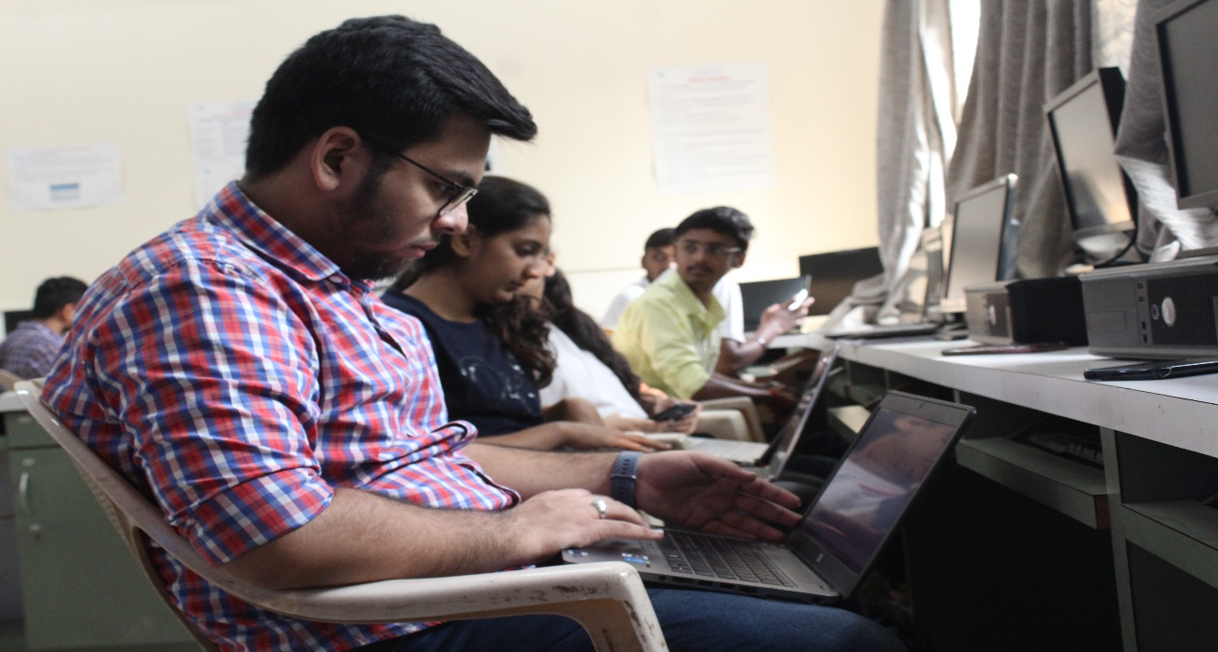
ISA VIT Pune hosted a data analytics workshop on 16th and 17th of November 2019, and left no stone unturned in making this event remarkable.

The objective was to make the idea clear about what is Data science, science behind Data analytics , the statistics involved , Exploratory Data analytics and Data visualisation in python. The motive was to make the students aware about the emerging field of data science and gather their interest.

The workshop was instructed by Mr. Pradip Tivhale (M. Tech IIT Madras), lead Data Science Trainer at Byte academy Bangalore. The students were indeed blessed to be guided by such an intellect.

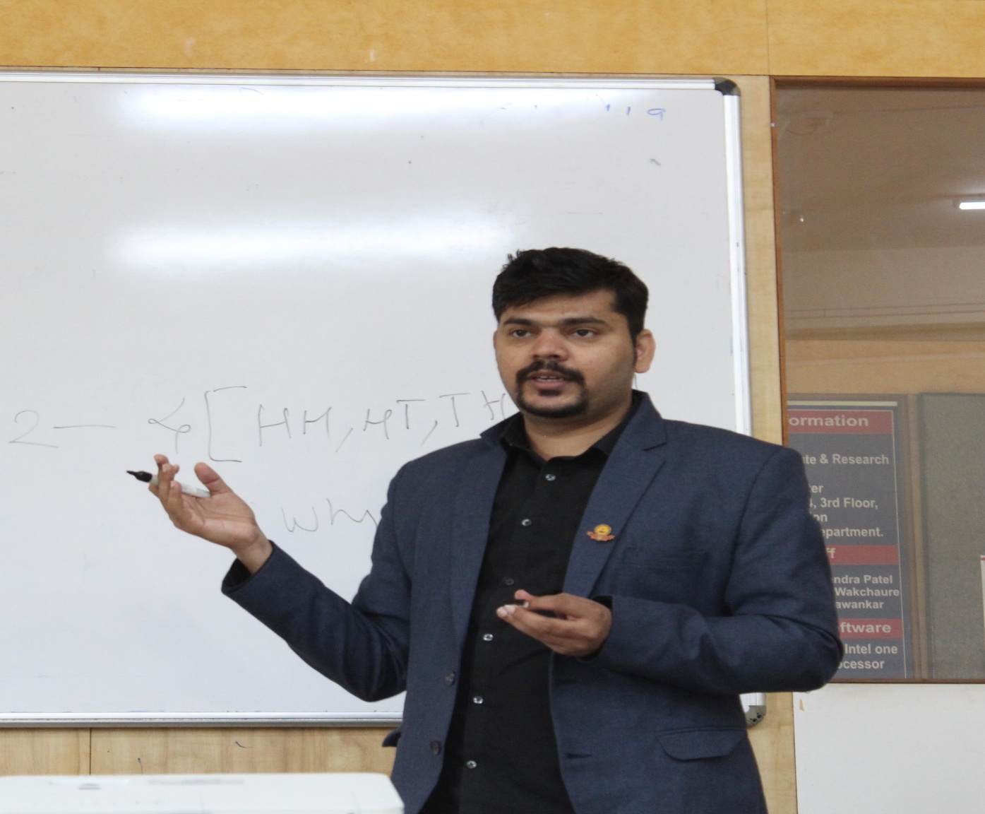
The publicity team worked 7 to 8 hrs a day, publicizing this event ,not only in VIT college but also setting publicity desks in MITand VIIT college as well. In colleges like AISSMS and Cummins the respective faculty advisors were a great help to spread the message. The posters designed by the multimedia and content team were displayed in colleges and also circulated through social media. The entire team put the efforts to make this event success. The objective the event was achieved .
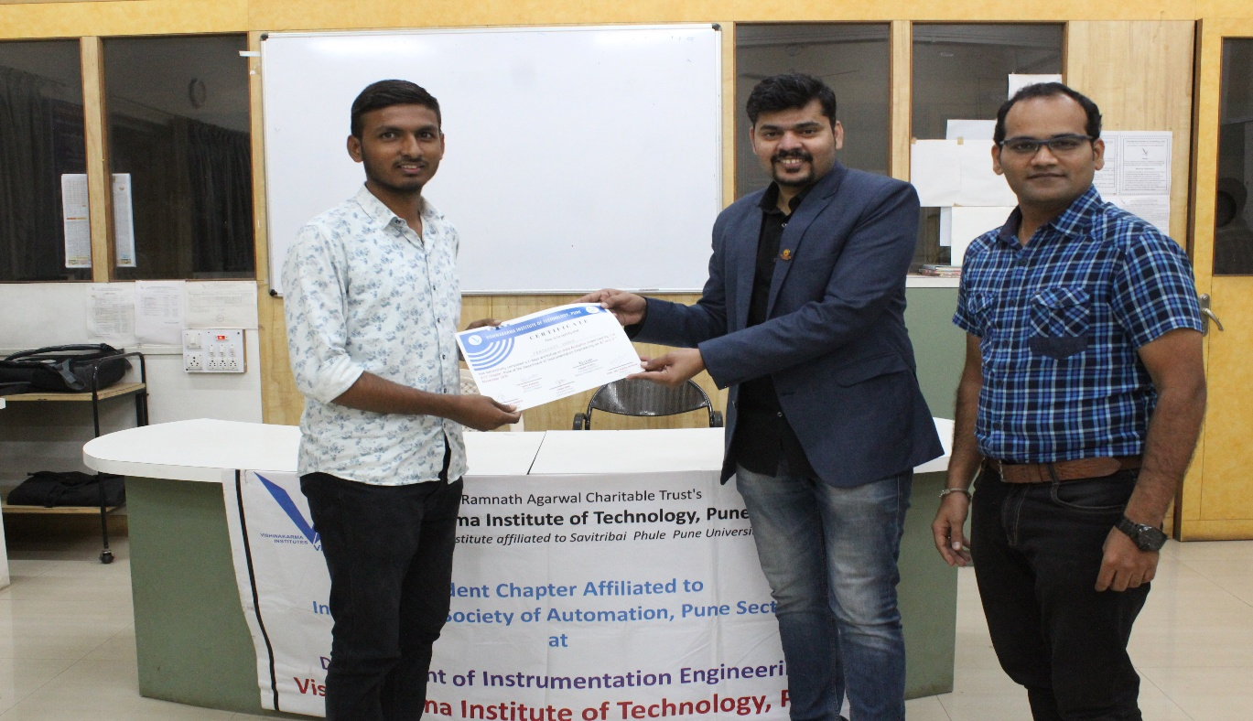
DA tools and techniques are increasingly necessary to harness new data sources. The availability of brand new techniques and technologies make a significant change in leveraging today's accessible computing power to enable the processing of large amounts and various types of data into relevant information through statistical analysis and modelling. Learning it requires proper guidance and patience which was there in this workshop.
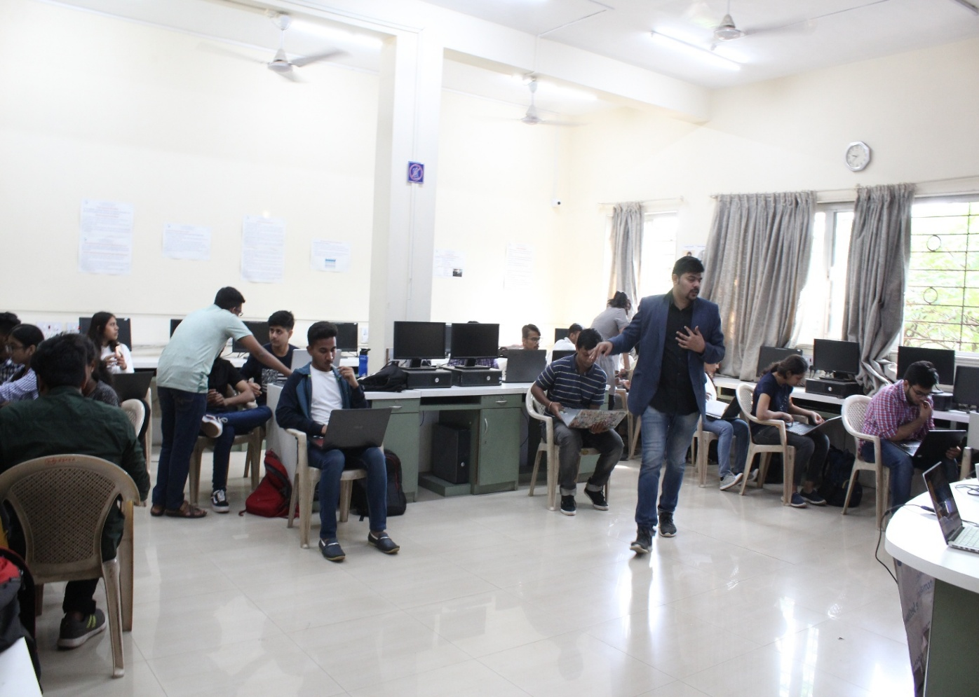
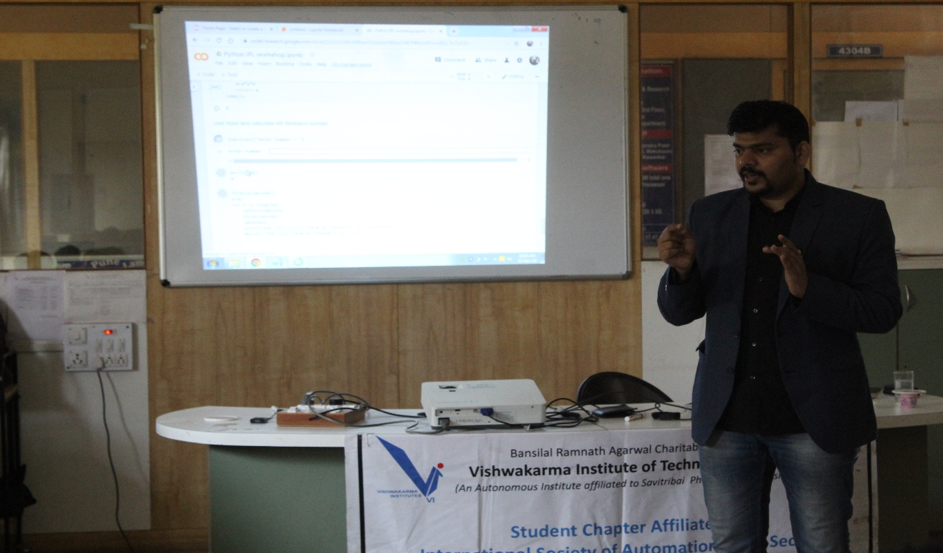

The feedback by the students after the event was quite overwhelming. Getting knowledge about such an upcoming field from an experienced trainer was itself a golden opportunity.

